

EUROPEAN AND MEDITERRANEAN PLANT PROTECTION ORGANIZATION
ORGANISATION EUROPEENNE ET MEDITERRANEENNE POUR LA PROTECTION DES PLANTES

18-23436 (17-23104)
Pest risk assessment for Cortaderia jubata

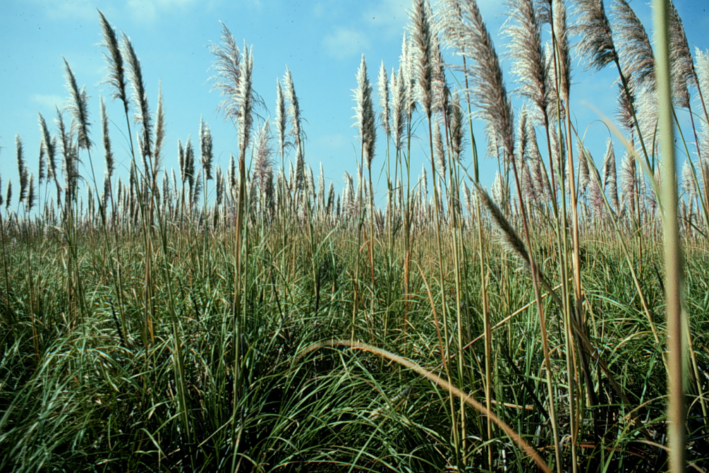

2018

EPPO
21 Boulevard Richard Lenoir
75011 Paris
www.eppo.int hq@eppo.int

This pest risk assessment scheme has been specifically amended from the EPPO Decision-Support Scheme for an Express Pest Risk Analysis document PM 5/5(1) to incorporate the minimum requirements for risk assessment when considering invasive alien plant species under the EU Regulation 1143/2014. Amendments and use are specific to the LIFE Project (LIFE15 PRE FR 001) ‘Mitigating the threat of invasive alien plants to the EU through pest risk analysis to support the Regulation 1143/2014’.

Photo: Dense stand of Cortaderia jubata (Image courtesy of John Lambrinos (US)

EUROPEAN AND MEDITERRANEAN PLANT PROTECTION ORGANIZATION

Pest risk assessment for Cortaderia jubata

This PRA follows EPPO Standard PM5/5 Decision support scheme for an Express Pest Risk Analysis

Composition of the Expert Working Group

BOUHACHE Mohamed (Mr) | Department of Plant Protection, Production and Biotechnogies, Institut Agronomique et Vétérinaire Hassan II, B.P. 6202 Rabat-Instituts, 10112 Rabat, Morocco, m.bouhache@gmail.com
Chapman Daniel (Dr) | Centre for Ecology and Hydrology Bush Estate, Penicuik, Edinburgh , UK, dcha@ceh.ac.uk
FOLLAK Swen (Mr) | Austrian Agency for Health and Food Safety (AGES), Institute for Sustainable Plant Production, Spargelfeldstraße 191, A-1220 Vienna, Austria, swen.follak@ages.at
LAMBRINOS John (Mr) | Department of Horticulture, Oregon State University, 4017 Agriculture and Life Sciences Building, OR 97331-7304 Corvallis, United States, john.lambrinos@oregonstate.edu
VAN VALKENBURG Johan (Mr) | National Plant Protection Organization, Geertjesweg 15, P.O. Box 9102, 6700 HC Wageningen, Netherlands, j.l.c.h.vanvalkenburg@nvwa.nl
VISSER Vernon (Mr) | Department of Statistical Sciences University of Cape Town, ​SEEC (Centre for Statistics in Ecology, the Environment and Conservation), Department of Statistical Sciences University of Cape Town Rondebosch, 7701 Cape Town, South Africa, vervis@gmail.com
YAACOBI Tuvia (Mr) | Research & Consultancy in Applied Ecology, Shahar st. Bldg 1, Appt 6, 96263 Jerusalem, Israel, tuvia.yaacoby@mail.huji.ac.il
TANNER Rob (Mr) | OEPP/EPPO, 21 boulevard Richard Lenoir, 75011 Paris, France, rt@eppo.int

The pest risk assessment for Cortaderia jubata has been performed under the LIFE funded project:

LIFE15 PRE FR 001

Mitigating the threat of invasive alien plants to the EU through pest risk analysis to support the Regulation 1143/2014

In partnership with

EUROPEAN AND MEDITERRANEAN PLANT PROTECTION ORGANIZATION

And

NERC CENTRE FOR ECOLOGY AND HYDROLOGY



Review Process

- This PRA on Cortaderia jubata was first drafted by Vernon Visser, SEEC (Centre for Statistics in Ecology, the Environment and Conservation), University of Cape Town, South Africa.

- The PRA was further evaluated by international experts which made up an Expert Working group that physically met in Paris in 2017.
- The PRA has been reviewed by the EPPO Panel on Invasive Alien Plants in 2017.
- The PRA has been reviewed by the EPPO Core Members on PRA 2018
- The PRA has been reviewed by the EU Scientific Forum (2018)

Approved by the IAS Scientific Forum on 26/10/2018

Contents
Summary 6
Stage 1. Initiation 9
Stage 2. Pest risk assessment 10
1. Taxonomy: 10
2. Pest overview 11
Socio-economic benefits 13
3. Is the pest a vector? 13
4. Is a vector needed for pest entry or spread? 13
5. Regulatory status of the pest 13
6. Distribution 15
7. Habitats and where they occur in the PRA area 17
8. Pathways for entry 19
9. Likelihood of establishment in the natural environment in the PRA area 21
10. Likelihood of establishment in managed environment in the PRA area 22
11. Spread in the PRA area 22
12. Impact in the current area of distribution 23
12.01 Impacts on biodiversity 23
12.02. Impact on ecosystem services 24
12.03. Socio-economic impact 25
13. Potential impact in the PRA area 25
13.01. Potential impacts on biodiversity in the PRA area 26
13.02. Potential impact on ecosystem services in the PRA area 26
13.03 Potential socio-economic impact in the PRA area 26
14. Identification of the endangered area 27
15. Climate change 27
15.01. Define which climate projection you are using from 2050 to 2100 27
15.02. Which component of climate change do you think is the most relevant for this organism? 27
15.03. Consider the influence of projected climate change scenarios on the pest. 27
16. Overall assessment of risk 28
17. Uncertainty 30
18. REFERENCES 31
Appendix 1: Projection of climatic suitability for Cortaderia jubata establishment 36
Appendix 2 Biogeographical regions 49
Appendix 3. Relevant illustrative pictures (for information) 50
Appendix 4: Distribution summary for EU Member States and Biogeographical regions 54
Appendix 5: Distribution maps 55

Summary of the Express Pest risk assessment for Cortaderia jubata
PRA area: EPPO-region
Describe the endangered area:
Cortaderia jubata is capable of establishing in the Atlantic, Black sea, Continental, and Mediterranean biogeographical regions. The countries suitable to the species include: Algeria, Belgium, Bulgaria, Croatia, Cyprus, France, Germany, Georgia, Greece, Hungary, Ireland, Israel, Italy, Morocco, Netherlands, Jordan, Portugal, Romania, Russia, Slovenia, Spain, Turkey, United Kingdom.

The expert working group (EWG) considers that the endangered area includes the Atlantic and Mediterranean biogeographical region, including the following countries in EU: Belgium, Bulgaria, Croatia, Cyprus, France, Germany, Greece, Hungary, Italy, Netherlands, Portugal, Romania, Slovenia, Spain, United Kingdom and in the wider EPPO area: Algeria, Georgia, Israel, Jordan, Morocco, Russia, Turkey (see appendix 1). Habitats at risk in the endangered area include: dune systems, grasslands, heathland, forests and woodlands, inland wetlands and along transportation networks (roadsides).
Main conclusions
Cortaderia jubata poses a moderate phytosanitary risk to the endangered area with a moderate uncertainty. The species was trialled as a horticultural species over 100 years ago in France and Ireland, but more recently (2009) in the UK. However, there is no evidence to suggest this species has established or is commercially available in the PRA area.

The likelihood of novel introductions occurring via seed or plant imports seems low given the current lack of commercial interest in this species.

Entry and establishment
The pathway plants for planting is the main pathway evaluated for this species and scored a low likelihood of entry with moderate uncertainty. This is due to the species not being readily available in trade. The species is not currently established within the EPPO region.

Cortaderia jubata is capable of establishing in the Atlantic, Black sea, Continental, and Mediterranean biogeographical region. The countries suitable to the species include: Algeria, Belgium, Bulgaria, Croatia, Cyprus, France, Germany, Georgia, Greece, Hungary, Ireland, Israel, Italy, Morocco, Netherlands, Jordan, Portugal, Romania, Russia, Slovenia, Spain, Turkey, United Kingdom.

Impacts in the current area of distribution
In California this species has been found to be able to displace native plant species once it has established (Peterson and Russo, 1988). Coastal sand dunes and inland sand hills are the most invaded habitats, and these harbour a number of rare and endangered plant species (Peterson and Russo, 1988). Associated with vegetation change is a decrease in arthropod abundance and diversity and rodents were less common in C. jubata-dominated grasslands, but rabbits more common (Lambrinos, 2000).

In Hawaiʽi it has been recorded as developing into “dense monotypic stands in mesic to humid areas with the potential to replace or compete with native species” (Daehler, 2006).

In Australia C. jubata has also been found to displace native plants (Queensland Government, 2017), although no empirical evidence has been published.

In New Zealand this species has been found to replace “ground cover, shrubs and ferns” (CABI, 2017).

Potential impacts in the PRA area
Cortaderia jubata is not known to have established in the PRA area and therefore has no impact in this area at present. However, were it to establish, it is very likely to have similar impacts (e.g. outcompeting native plants and negatively affecting forestry operations). C. jubata has a broad environmental tolerance and therefore has the potential to occur in many different habitat types in the PRA area. This will relate equally to EU Member States and non-EU Member States in the EPPO region.

The results of this PRA show that Cortaderia jubata poses a moderate risk to the endangered area (Atlantic, Black sea, Continental, and Mediterranean biogeographical region) with a moderate uncertainty.

The EWG considers that the endangered area includes the Atlantic and Mediterranean biogeographical region including the following countries: Algeria, Belgium, Bulgaria, Croatia, Cyprus, France, Germany, Georgia, Greece, Hungary, Israel, Italy, Jordan, Morocco, Netherlands, Portugal, Romania, Russia, Slovenia, Spain, Turkey, United Kingdom (see appendix 1). Habitats at risk in the endangered area include: dune systems, grasslands, heathland, forests and woodlands, inland wetlands and transportation networks (roadsides).

Climate change
Under climate change, Cortaderia jubata is capable of establishing in the Atlantic, Black sea, Continental, Macaronesia, Mediterranean, Pannonian and Steppic biogeographical region and the Anatolian biogeographical region. The countries where the species has a high suitability include: Algeria, Austria, Belgium, Bulgaria, Croatia, Cyprus, Czech Republic, Denmark, France, Germany, Georgia, Greece, Hungary, Ireland, Israel, Italy, Luxembourg, Malta, Morocco, Netherlands, Norway, Poland, Portugal, Romania, Russia, Slovakia, Slovenia, Spain, Sweden, Turkey, United Kingdom. The influence of projected climate change scenarios has not been taken into account in the overall scoring of the risk assessment based on the high levels of uncertainty with future projections.

Phytosanitary risk (including impacts on biodiversity and ecosystem services) for the endangered area (current/future climate)  Pathway for entry  Plants for planting (horticulture): Low/ Low  Plant for planting (fodder) Low/Low  Likelihood of establishment in natural areas: High /High  Likelihood of establishment in managed areas: High/ High  Spread: High/ High  Impacts in the current area of distribution  Biodiversity and environment: Moderate/Moderate  Ecosystem services: Moderate/Moderate  Socio-economic: Moderate/Moderate  Impacts (EPPO region)  Biodiversity and environment: Moderate/Moderate  Ecosystem services: Moderate/Moderate  Socio-economic: Moderate/Moderate | High  ☐ | Moderate  X | Low  ☐
Level of uncertainty of assessment (current/future climate)  Pathway for entry  Plants for planting (horticulture): Moderate/Moderate  Plant for planting (fodder) Moderate/Moderate  Likelihood of establishment in natural areas: Low/Low  Likelihood of establishment in managed areas: Low/Low  Spread: Low/Low  Impacts in the current area of distribution  Biodiversity and environment: Low/Low  Ecosystem services: Moderate/Moderate  Socio-economic: Moderate/Moderate  Impacts (EPPO region)  Biodiversity and environment: High/High  Ecosystem services: High/High  Socio-economic: High/High | High  ☐ | Moderate  X | Low  ☐
Other recommendations:

- Due to the difficulty of identifying Cortaderia species in trade, the EWG recommend identification tools (bar coding, macromorphology) are developed to support the recommendations of the PRA and any further listings.

Express Pest risk assessment:
…………..
(Cortaderia jubata)
Prepared by:
First draft: Vernon Visser, SEEC (Centre for Statistics in Ecology, the Environment and Conservation), University of Cape Town, South Africa. Email: vervis@gmail.com

Date:
1/9/2017

Stage 1. Initiation

Reason for performing the PRA:

Cortaderia jubata is a perennial grass species native to Argentina, Chile, Bolivia, Ecuador, Peru and Colombia (Testoni & Villamil, 2014). C. jubata is invasive in California, Hawai‘i, New Zealand, Australia and South Africa, but appears to have had the largest impacts in New Zealand and California. In New Zealand, C. jubata has substantial impacts on plantation forestry by competing with forestry trees and making access to plantations more difficult (Gadcil et al., 1984).

Cortaderia jubata was included in a list of 95 invasive alien species that are likely to “arrive, establish, spread and have an impact on biodiversity or related ecosystem services in the EU over the next decade” (Roy et al., 2015). In 2016, the species was prioritized (along with 36 additional species from the EPPO List of Invasive Alien Plants and a recent horizon scanning study) using a prioritization process for invasive alien plant species which incorporated the requirements of the EU Regulation no. 1143/2014 (Branquart et al., 2016), for PRA within the LIFE funded project “Mitigating the threat of invasive alien plants to the EU through pest risk analysis to support the Regulation 1143/2014’. C. jubata was one of 16 species identified as having a high priority for PRA (Tanner et al., 2017).

PRA area: EPPO region (see https://www.eppo.int/ABOUT_EPPO/images/clickable_map.htm)

The risk assessments were prepared according to EPPO Standard PM5/5 (slightly adapted) which has been approved by the 51 EPPO Member Countries, and which sets out a scheme for risk analysis of pests, including invasive alien plants (which may be pests according to the definitions in the International Plant Protection Convention). EPPO engages in projects only when this is in the interests of all its member countries, and it was made clear at the start of the LIFE project that the PRA area would be the whole of the EPPO region. Furthermore, we believe that since invasive alien species do not respect political boundaries, the risks to the EU are considerably reduced if neighbouring countries of the EPPO region take equivalent action on the basis of broader assessments and recommendations from EPPO.

All information relating to EU Member States is included in the Pest risk assessment and information from the wider EPPO region only acts to strengthen the information in the PRA document. The PRA defines the endangered area where it lists all relevant countries within the endangered area, including EU Member States. The distribution section lists all relevant countries in the EPPO region (including by default those of EU Member States and biogeographical regions which are specific to EU member States). Habitats and where they occur in the PRA are defined by the EUNIS categorization which is relevant to EU Member States. Pathways are defined and relevant to the EU Member States and the wider EPPO Member countries, and where the EWG consider they may differ between EU Member States and non-EU EPPO countries, this is stated. The establishment and spread sections specifically detail EU Member States. When impacts are relevant for both EU Member States and non-EU EPPO countries this is stated ‘The text within this section relates equally to EU Member States and non-EU Member States in the EPPO region’. Where impacts are not considered equal to EU Member States and non-EU Member States this is stated and further information is included specifically for EU member States. For climate change, all countries (including EU Member States) are considered.

Stage 2. Pest risk assessment

1. Taxonomy:
Cortaderia jubata (Lemoine ex Carrière) Stapf (Kingdom Plantae; Phylum Tracheophyta; Class Liliopsida; Order Poales; Family Poaceae.

EPPO code: CDTJU

Common names: Andean pampas grass, Andes grass, Jubatagrass, jubata grass, pampas grass, pink pampas grass, purple pampas grass, Selloa grass, pampasgras (Afrikaans), cortadera, sacuara (Spanish)

Synonomy: Cortaderia atacamensis (Phil.) Pilg., Cortaderia selloana subsp. jubata (Lemoine) Testoni & Villamil, Gynerium jubatum Lemoine ex Carrière, Gynerium pygmaeum Meyen, Gynerium quila var. pygmaeum Nees
Refs: The Plant List (http://www.theplantlist.org/tpl1.1/record/kew-405788), The PLANTS Database (https://plants.usda.gov/core/profile?symbol=COJU2).

Note: Testoni & Villamil (2014) provided evidence that Cortaderia jubata (Lemoine ex Carrière) Stapf “represents only a portion of the morphologic variability of C. selloana” and should therefore be recognised as a subspecies of the latter (Cortaderia selloana subsp. jubata (Lemoine) Testoni & Villamil). In the most recent revision of the genus Cortaderia, Testoni & Linder (2017) upheld this reclassification. There is also considerable identification uncertainty in regions where both taxa are introduced (e.g. DiTomaso et al., 2003; Houliston & Goeke, 2017), and Lambrinos (2001) suggested that the floral traits of C. selloana in California have gradually become more similar to that of C. jubata over the previous 80 years. However, apart from the two aforementioned references in all of the literature, web references and databases assessed during the preparation of this PRA, C. jubata is still referred to at the species level. Moreover, regardless of the specific or sub-specific classification of C. jubata, specific morphological, reproductive and phenological characters are used to distinguish this taxon from C. selloana (e.g. Houliston & Goeke, 2017, Lambrinos, 2001; Testoni & Linder, 2017). This PRA therefore follows the nomenclature of Otto Stapf (1898) for this taxon: Cortaderia jubata (Lemoine ex Carrière) Stapf.

Related species in the EPPO region:

Native species: None

Species in trade: Cortaderia fulvida, C. selloana, C. richardii

Note: recently C. fulvida and C. richardii have been moved to the Genus Austroderia

Related species in the EPPO region: C. selloana,

2. Pest overview

Introduction
Cortaderia jubata is a perennial grass species native to Argentina, Chile, Bolivia, Ecuador, Peru and Colombia (Testoni & Villamil, 2014). It can grow up to 4 m in height and has large, serrated leaves and a tall, fluffy inflorescence (sometimes referred to as a plume) (Clayton et al., 2006 onwards; Edgar & Connor, 2000).

Reproduction
Only female plants of C. jubata are known to occur and this species reproduces from seeds produced from unfertilised female ovules (apomixis) (Testoni & Linder, 2017). C. jubata is extremely fecund, producing over 100 000 seeds from a single inflorescence in one season, with an adult plant having between five and 20 inflorescences (Drewitz & DiTomaso, 2004). Seeds are dispersed principally by wind, but also by water and animals (Drewitz & DiTomaso, 2004; New Zealand Plant Conservation Network, 2017). Seeds buried under natural conditions remain viable for a very limited period (no longer than four months; Drewitz & DiTomaso, 2004).

Environmental requirements
Cortaderia jubata has a very broad environmental tolerance: it can tolerate severe drought but establishes best in “wet, sandy soil without existing vegetation” (Peterson & Russo, 1988) and has been shown to germinate best in high light, warm (~20º C) and moist conditions (Stanton & DiTomaso, 2004). C. jubata is sensitive to drought as a seedling (Stanton & DiTomaso, 2004), but is able to tolerate dry conditions as an adult plant (e.g. Loope & Medeiros, 1992). There is some indication that C. jubata is sensitive to frost: it did not survive horticultural trials in Ireland (Hooker, 1898) and it suffers leaf damage when frosted (Costas Lippmann, 1977; Robinson, 1984). However, frost rarely leads to plant mortality (Costas Lippmann, 1977; Robinson, 1984). C. jubata grows in a wide variety of soils (Cal-IPC, 2017).

Habitats
In its native range this species usually grows at high altitudes (~2000 to 3900 m) in the Andes and is said to often form dense stands bordering high altitude montane forests (Instituto de Botánica Darwinion, 2017; Testoni & Villamil, 2014). In its alien ranges of California, Hawai‘i, Australia, New Zealand and South Africa, C. jubata occupies a wide range of habitats (see Section 7), but is particularly common in disturbed environments (Cal-IPC, 2017; Loope & Medeiros, 1992; Parsons & Cuthbertson, 2004; Robinson, 1984).

Identification
This species is a tall, tussock-forming grass with sharp, drooping, serrated leaves and a tall, fluffy inflorescence that is usually pink to violet in colour, but turning brown with age (see Appendix 3, Fig. 1). It is morphologically similar to C. selloana. The two taxa have broadly overlapping introduced ranges, with the notable exception of the EPPO region where only C.selloana has been reported as naturalized. Although studies using both morphological (Testoni and Linder 2017) and genetic (Houliston and Goeke 2017) traits have identified distinct taxonomic groupings, distinguishing individuals of the two taxa is difficult. Diagnostic traits are often subtle and only present during certain life history stages. In addition, the validity of many diagnostic traits varies across regions in the introduced range. This might reflect the high degree of morphological variability across the native range of C. selloana as well as the morphological diversity of its cultivated selections.

When inflorescences are present, C. jubata can generally be distinguished from C. selloana by inflorescences that extend well above the foliage (Appendix 3, Figure 1) and young inflorescences that are violet hued rather than purely white or yellow as they are in C. selloana (Edgar & Connor, 2000; Testoni & Linder, 2017). However, individuals of both taxa appear to express a high degree of phenotypic plasticity in these traits. Regional taxonomic treatments have identified a number of other potentially discriminating traits including: leaf blades in C. jubata that are dark green on both sides but blue green above and dark green below in C. selloana (http://floraseries.landcareresearch.co.nz/pages/index.aspx); leaf tips that are not setaceous in C. Jubata but markedly so in C. selloana (Robinson 1984); and a range of floral characteristics (See Appendix 3, Plate 1 & 2). However, the cross-region reliability of these diagnostic traits is not known.

Symptoms
Cortaderia jubata is invasive in California, Hawai‘i, New Zealand, Australia and South Africa, but appears to have had the largest impacts in New Zealand and California (see section 6 for supporting references). In New Zealand, C. jubata has substantial impacts on plantation forestry by competing with forestry trees and making access to plantations more difficult (Gadcil et al., 1984). C. jubata has also been mentioned as affecting forestry operations in California (Madison, 1992) and in Tasmania, Australia (Harradine, 1991). C. jubata has also been mentioned as exacerbating asthma (from its many wind-dispersed seeds) and harbouring vermin (Government of South Australia, 2011; NSW Government, 2017). This species outcompetes native vegetation, reducing plant diversity and changing vegetation structure (Lambrinos, 2000; Peterson & Russo, 1988).

Relevant PRAs
Australia: Using the Victorian Weed Risk Assessment method, The State of Victoria (2017a) found C. jubata to be highly likely to invade natural areas (with high confidence), to be highly tolerant of fire and drought (as adult plants) (with moderately high confidence), to be highly likely to produce large numbers of propagules and reach reproductive age quickly, and to be highly likely to disperse both far and via a number of different mechanisms. C. jubata was also found to be likely to have significant impacts, including restricting human access, changing vegetation composition, structure and diversity, and likely to affect forestry productivity (The State of Victoria, 2017b).

France: In 2010, C. jubata was identified as a priority species among 36 other invasive alien plant species that could potentially be added to the EU directive 2000/29/CE of 8 May 2000 and transposed under French law by the ministerial decree of 24 March 2006, in case the revision process of the Common Plant Health Regime (CPHR) adopt the option of including invasive plants with environmental impacts (NB: this option was not retained since these species were later covered by the IAS EU Regulation) (Fried et al., 2010). The motivation for adding the aforementioned 36 species to the CPHR list was their high scores on the risk assessment index of Weber & Gut (2004). C. jubata had the 4th highest score of all assessed species (32 out of a maximum of 39) and was found to have a high risk of causing large environmental impacts (Fried et al., 2010).

California: The California Invasive Plant Council (Cal-IPC) Inventory rating for Cortaderia jubata is “high”, which has the following meaning: “These species have severe ecological impacts on physical processes, plant and animal communities, and vegetation structure. Their reproductive biology and other attributes are conducive to moderate to high rates of dispersal and establishment. Most are widely distributed ecologically”. C. jubata was given high scores for impacts on plant communities and higher tropic levels, rapid rate of spread, high reproductive potential, high potential for human-caused and long-distance natural dispersal, and for having a broad environmental tolerance (Stanton et al., 2005).

US (overall): The U.S. Department of Agriculture Weed Risk Assessment rated C. jubata as High Risk, using the PPQ WRA model (USDA 2014). It was given high scores for establishment and impact risk potentials.

Hawaiʽi: Using the Australian/New Zealand Weed Risk Assessment adapted for Hawai‘i, Cortaderia jubata obtained a high score of 26, which is well above the rejection score of >6 (Daehler, 2006).

Socio-economic benefits
Cortaderia jubata has been most commonly planted as an ornamental species because of its large, colourful inflorescences (e.g. Costas Lippmann, 1977). The species was trialled (2009) as an ornamental species by Wisely Gardens (RHS) in the UK (Royal Horticultural Society, 2009). One reason why the species may not have been grown and promoted widely in trade is due to C. jubata being less pretty and the flowers being messier than C. selloana (pers. comm. J. Lambrinos). In the EPPO region, the species is not currently available from nurseries. Seeds can be purchased from online suppliers from outside of the EPPO region (for example, https://www.amazon.com/PAMPAS-GRASS-Cortaderia-jubata-seeds/dp/B00480KMME).

It has also been used as a forage plant in New Zealand (Gadcil et al., 1984). It has been suggested that this species has also been planted “for shelter belts, land protection and erosion control” (CABI, 2017). “Pampas grass” was planted for mine rehabilitation in South Africa long before it was realised that there were in fact two species (C. jubata and C. selloana) in the country, so it is highly possible that the former was introduced for this purpose as well (Robinson, 1984).

3. Is the pest a vector? | Yes |  | No | X

4. Is a vector needed for pest entry or spread? | Yes |  | No | X

5. Regulatory status of the pest

Australia: In New South Wales C. jubata is regulated as a weed with a “general biosecurity duty” under the Biosecurity Act 2015. All plants listed under this legislation are regulated with a “duty to prevent, eliminate or minimise any biosecurity risk they may pose. Any person who deals with any plant, who knows (or ought to know) of any biosecurity risk, has a duty to ensure the risk is prevented, eliminated or minimised, so far as is reasonably practicable” (https://www.legislation.nsw.gov.au/acts/2015-24.pdf).

In South Australia C. jubata is listed as a “State Alert Weed”. These “are invasive weeds that are not known to be in South Australia, or if present, occur in low numbers in a restricted area and are still capable of being eradicated. An Alert Weed would pose a serious threat to the State’s primary industries, natural environments or human health if it became established here. All Alert Weeds are declared under the Natural Resources Management Act 2004: their transport and sale are prohibited (Sect. 175 and 177), plants must be destroyed (Sect. 182), and if found on your land their presence must be notified to NRM authorities (Sect. 180) (https://www.legislation.sa.gov.au/LZ/C/A/Natural%20Resources%20Management%20Act%202004.aspx).

In Tasmania C. jubata is a “Declared Weed” under the Weed Management Act, 1999. Declared Weeds have the following relevant requirements: (1) “A person must not import, or allow to be imported, into the State any declared weed except with the written approval of the Secretary”; (2) “Landowners and managers must take all reasonable measures to control the impact and spread of a declared weed”; (3) “A person must not propagate, trade or otherwise distribute declared weeds or anything carrying declared weeds except - (I) transport for purposes of disposal and (II) sale or transport for purposes other than disposal where authorised by the Secretary”; (4)” A declared weed must be disposed of in a manner which will not result in further infestation”; (5) “A declared weed must be eradicated from areas of the State where this is considered feasible” (http://dpipwe.tas.gov.au/invasive-species/weeds/weed-legislation-and-management-plans/about-the-weed-management-act#DeclaredWeeds).

Europe (overall): At present, there is no regulatory status in Europe for this species. Cortaderia jubata has been included in a list of 95 invasive alien species that are likely to “arrive, establish, spread and have an impact on biodiversity or related ecosystem services in the EU over the next decade” (Roy et al., 2015).

New Zealand: Cortaderia jubata is listed on the National Pest Plant Accord, which is a statutory list as mandated by the Biosecurity Act 1993. Species on this list are not allowed to be sold, distributed or propagated (http://www.mpi.govt.nz/protection-and-response/long-term-pest-management/national-pest-plant-accord/).

South Africa: In South Africa, control of the species is enabled by the National Environmental Management: Biodiversity (NEMBA) Act 10 of 2004. Currently C. jubata is listed as a “Category 1b invasive species” on the NEMBA-mandated “Alien and Invasive Species Lists, 2016”. Category 1b invasive species may not be imported into South Africa, grown, bred or otherwise propagated, moved or translocated in any manner, sold, traded or given away. Category 1b species are major invaders that possibly require government support in order to be removed. The spread or allowing the spread of any Category 1b species is prohibited (NEMBA Act 10 of 2004, www.environment.gov.za).

USA: In Hawaiʽi C. jubata is listed as a “Noxious Weed” as defined in Chapter 152, Hawaiʽi Revised Statutes: “any plant species which is, or which may be likely to become, injurious, harmful, or deleterious to the agricultural, horticultural, aquacultural, or livestock industry of the State and to forest and recreational areas and conservation districts of the State, as determined and designated by the department from time to time” (http://dlnr.hawaii.gov/hisc/info/policy/).

In Colorado this species is on the State Noxious Weed Watch List, which includes species that are “known to be invasive in areas near Colorado but are not known to occur here or whose distribution is not yet fully understood” (http://www.cwma.org/noxweeds.html).

In Oregon this species is a “B Listed Weed”, which includes species that are “a weed of economic importance which is regionally abundant, but which may have limited distribution in some counties” (http://www.oregon.gov/ODA/shared/Documents/Publications/Weeds/NoxiousWeedPolicyClassification.pdf).

In Washington State, this species is a “Class C Weed”. These species “are often widespread, or are of special interest to the agricultural industry”. “The State Weed Board does not require control of” these species, but the “State and many County Weed Boards provide information on identification and best management practices for these species”, and “a County Weed Board may require landowners to control a Class C weed if it poses a threat to agriculture or natural resources” (http://www.nwcb.wa.gov/washingtons-noxious-weed-laws).

6. Distribution
Continent | Distribution | Provide comments on the pest status in the different countries where it occurs | Reference
Africa | South Africa | Introduced, established and invasive. | Henderson (2007); Robinson (1984)
America | North America: USA (California, Hawaiʽi, Oregon, Washington) | Introduced, established and invasive. | Lambrinos (2000, 2001); USDA (2017)
 | South America: Argentina, Bolivia, Chile, Colombia, Ecuador, Peru | Native | Testoni & Villamil (2014); USDA (2017)
Asia | No occurrences
Europe | France | Introduced. Was cultivated, has not established. | Hooker (1898)
 | Ireland | Introduced. Was cultivated, has not established. | Hooker (1898)
 | Spain | Introduced. Only cultivated, has not established. | USDA, NPGS (2017)
 | UK | Introduced. Only cultivated, has not established. | Royal Horticultural Society (2009)
Oceania | Australia: New South Wales, South Australia, Tasmania, Victoria, Western Australia | Introduced, established and invasive. | Parsons & Cuthbertson (2004), Western Australian Herbarium (1998–)
 | New Zealand | Introduced, established and invasive. | Edgar & Connor (2000), Houliston & Goeke (2017)

North America
In North America, Cortaderia jubata is non-native and invasive in California, Oregon and Washington States. In addition, the species is invasive in Hawai’i.

South America
Cortaderia jubata is native to South America, including Argentina, Bolivia, Chile, Colombia, Ecuador and Peru. In its native range this species usually grows at high altitudes (~2000 to 3900 m) in the Andes and is said to often form dense stands bordering high altitude montane forests (Instituto de Botánica Darwinion, 2017; Testoni & Villamil, 2014).

Asia
The species is absent from Asia.

Africa
Pampas grass was planted for mine rehabilitation in South Africa long before it was realised that there were in fact two species (C. jubata and C. selloana) in the country, so it is highly possible that the former was introduced for this purpose as well (Robinson, 1984).

Europe
The species is absent from Europe in the natural environment. The species first reported from Europe in the 1800s (as an ornamental species) (Carrieré, 1878).

Oceania
Cortaderia jubata is present as a non-native species in Australia and New Zealand.

7. Habitats and where they occur in the PRA area

Habitat (main) | EUNIS habitat types | Status of habitat (e.g. threatened or protected) | Is the pest present in the habitat in the PRA area (Yes/No) | Comments (e.g. major/minor habitats in the PRA area) | Reference
Dunes | B1: Coastal dunes and sandy shores Yes, in part | Yes, in part | No | Major | Cal-IPC (2017); NSW Government (2017); Popay et al. (2003)
Grassland | E: Grassland and tall forb | Yes, in part | No | Major | Invasive Species South Africa (2017); Parsons & Cuthbertson (2004); Peterson & Russo (1988)
Heathland | F: Heathland, scrub and tundra  F3: Temperate and Mediterranean-montane scrub  F4: Temperate shrub heathland | Yes, in part | No | Major | Cal-IPC (2017); NSW Government (2017)
Forest | G: Woodland, forest and other wooded land | Yes, in part | No | Major | DiTomaso et al. (2008); Gadcil et al. 1984; Parsons & Cuthbertson (2004)
Inland wetland | D: Mires, bogs and fens | Yes, in part | No | Major | Gosling et al. (2000); Lambrinos (2001); NSW Government (2017)
Roadsides | E5.1 Herbaceous weed vegetation | No | No | Major | Cal-IPC (2017); Loope & Medeiros (1992); Parsons & Cuthbertson (2001); Robinson (1984)

Cortaderia jubata invades a wide variety of habitats. It is particularly known for invading disturbed/ruderal areas such as roadsides, logged forests/plantations and recently burnt vegetation (Edgard & Connor, 2000; Parsons & Cuthbertson, 2001; Robinson, 1984; Starr et al., 2003). However, it is also capable of invading a number of habitats in intact vegetation, with a preference for sunnier, more open vegetation types, possibly due to increased seed germination and seedling survival in sunnier conditions (Drewitz & DiTomaso, 2004; Stanton & DiTomaso, 2004). Habitat associations do however seem to differ slightly from region to region. In California, this species is most commonly associated with disturbed habitats and then with coastal chaparral and wetlands (Lambrinos, 2001; Peterson & Russo, 1988). In New Zealand, this species appears to occupy the highest diversity of habitats with the New Zealand Plant Conservation Network (2017) stating that it occurs in “forest light gaps, slips, margins, disturbed sites, open habitats, riverbeds, cliffs, inshore and offshore islands, tussockland, fernland, herbfield, duneland, coastline, gumlands, salt marsh, estuaries, shrublands”. In Australia C. jubata seems to be most commonly associated with disturbed habitats: roadsides, “disturbed bushland” (NSW Government, 2017) and “burnt-over forests” (Government of South Australia, 2011). In Maui, Hawaiʽi this species is also associated with roadsides, but has been found spreading into dry, alpine desert and moist subtropical montane forest (Loope & Medeiros, 1992). In South Africa this species is once again associated with disturbed habitats, but also invades native grasslands (Invasive Species South Africa, 2017; Robinson, 1984).

8. Pathways for entry (in order of importance)

Possible pathway | Pathway: Plants or seeds for planting  (CBD terminology: Escape from confinement - horticulture)
Short description explaining why it is considered as a pathway | Cortaderia jubata has been historically planted as an ornamental in France, Ireland, the UK (Hooker, 1898; Royal Horticultural Society, 2009), Australia (Queensland Government, 2017), California (Costas Lippmann 1977; Peterson & Russo, 1988), New Zealand (Houliston & Goeke, 2017) and South Africa (Robinson, 1984). There is no evidence that the species is promoted as an ornamental plant within the EPPO region but it has been trialled as an ornamental species by Wisely Gardens (RHS) in the UK (Royal Horticultural Society, 2009)..
Is the pathway prohibited in the PRA area? | Not currently prohibited in the PRA area as a whole.
Has the pest already been intercepted on the pathway? | Yes, the species has recently (2009) been trialled as an ornamental species by Wisely Gardens (RHS) in the UK (Royal Horticultural Society, 2009).
What is the most likely stage associated with the pathway? | Seeds and juvenile plants.
What are the important factors for association with the pathway? | In the EPPO region, the species is not currently available from nurseries. Seeds can be purchased from online suppliers from outside of the EPPO region (for example, https://www.amazon.com/PAMPAS-GRASS-Cortaderia-jubata-seeds/dp/B00480KMME).  The EWG note that C. selloana (commonly found in trade within the EU) and C. jubata can be easily confused and therefore one species may be misidentified for another. Misidentification of C. jubata and C. selloana is possible even by experts. In California, populations of C. selloana were commonly misidentified as C. jubata in botanical treatments (Lambrinos 2001).
Is the pest likely to survive transport and storage along this pathway? | Yes, live plants can survive but seeds do not have a significant dormant period with highest germination rates occurring after two to ten days (Chimera, 1999). Only 2 % of seeds were shown to germinate after a period of five months (Chimera, 1999).
Can the pest transfer from this pathway to a suitable habitat? | Yes, if planted in managed environments the seeds could disperse via wind to suitable habitats.
Will the volume of movement along the pathway support entry? | It is unlikely that the volume of movement will support entry as the species is not available in trade within the region and there are limited online suppliers outside of the region.
Will the frequency of movement along the pathway support entry? | It is unlikely that the frequency of movement will support entry as the species is not available in trade within the region and there are limited online suppliers outside of the region.
Rating of the likelihood of entry | Low X Moderate ☐ High ☐
Rating of uncertainty | Low ☐ Moderate X High ☐

As the species may be imported as a commodity, all European biogeographical regions will have the same likelihood of entry and uncertainty scores.

Possible pathway | Pathway: Plants or seeds for planting  (CBD terminology: Release in nature - Landscape/flora/fauna “improvement” in the wild )
Short description explaining why it is considered as a pathway | Cortaderia jubata has been planted as a forage plant in California (Peterson & Russo, 1988) and New Zealand (Gadcil et al., 1984). There is no evidence that the species is promoted as forage plant within the EPPO region.
Is the pathway prohibited in the PRA area? | Not currently prohibited in the PRA area as a whole.
Has the pest already been intercepted on the pathway? | No, the species has not been intercepted as a forage species on in the EPPO region.
What is the most likely stage associated with the pathway? | Seeds and juvenile plants.
What are the important factors for association with the pathway? | Seeds can be purchased from online suppliers from outside of the EPPO region (for example, https://www.amazon.com/PAMPAS-GRASS-Cortaderia-jubata-seeds/dp/B00480KMME).
Is the pest likely to survive transport and storage along this pathway? | Yes, live plants can survive but seeds do not have a significant dormant period with highest germination rates occurring after two to ten days (Chimera, 1999). Only 2 % of seeds were shown to germinate after a period of five months (Chimera, 1999).
Can the pest transfer from this pathway to a suitable habitat? | Yes, if planted in managed environments the seeds could disperse via wind to suitable habitats.
Will the volume of movement along the pathway support entry? | It is unlikely that the volume of movement will support entry as the species is not available in trade within the region and there are limited online suppliers outside of the region.
Will the frequency of movement along the pathway support entry? | It is unlikely that the volume of movement will support entry as the species is not available in trade within the region and there are limited online suppliers outside of the region.
Rating of the likelihood of entry | Low X Moderate ☐ High ☐
Rating of uncertainty | Low ☐ Moderate X High ☐

As the species may be imported as a commodity, all European biogeographical regions will have the same likelihood of entry and uncertainty scores.

9. Likelihood of establishment in the natural environment in the PRA area

C. jubata has a very broad environmental tolerance: it can tolerate severe drought but it establishes best in “wet, sandy soil without existing vegetation” (Peterson & Russo, 1988) and has been shown to germinate best in high light, warm (~20º C) and moist conditions (Stanton & DiTomaso, 2004). C. jubata is sensitive to drought as a seedling (Stanton & DiTomaso, 2004), but is able to tolerate dry conditions as an adult plant (e.g. Loope & Medeiros, 1992). There is some indication that C. jubata is sensitive to frost: it did not survive horticultural trials in Ireland (Hooker, 1898) and it suffers leaf damage when frosted (Costas Lippmann, 1977; Robinson, 1984). However, frost rarely leads to plant mortality (Costas Lippmann, 1977; Robinson, 1984). C. jubata grows in a wide variety of soils (Cal-IPC, 2017).

In its native range this species usually grows at high altitudes (~2000 to 3900 m) in the Andes and is said to often form dense stands bordering high altitude montane forests (Instituto de Botánica Darwinion, 2017; Testoni & Villamil, 2014). In its alien ranges of California, Hawai‘i, Australia, New Zealand and South Africa, C. jubata occupies a wide range of habitats (see Section 7), but is particularly common in disturbed environments (Cal-IPC, 2017; Loope & Medeiros, 1992; Parsons & Cuthbertson, 2004; Robinson, 1984).

The species is thought not to have established in the PRA area. However, given the high chances for confusion with C. selloana (which has a different altitudinal native range (seas level to 1 900 m asl compared to C. jubata 2 800 to 3 400 m asl) (see Section 1 Note), which is established in much of southern Europe, northern Africa, Turkey, the Caucasus, the Canary Islands, Madeira and the Azores (Euro+Med, 2006-), and given that C. jubata was trialled as an ornamental in France, Ireland and the UK (See Section 6), it is possible that this species is already established in the PRA area.

Natural areas most at risk of invasion by this species within the PRA region are probably riparian and wetland areas, heathlands, shrublands, coastal dunes (See Section 7).

Climatic conditions within parts of the current distribution of the species are similar to the PRA area, for example New Zealand. The projection of suitability in Europe and the Mediterranean region suggests that C. jubata may be capable of establishing widely in southern and western Europe and in north Africa, the Middle East and around the Black and Caspian Seas (Figure 5, Appendix 1). In eastern and northern Europe (Scandinavia), low suitability is predicted because the model considers cold winters would limit establishment (Figure 6, Appendix 1).

In terms of Biogeographical Regions (Bundesamt fur Naturschutz (BfN), 2003), those predicted to be most suitable for C. jubata establishment in the current climate are Mediterranean, Atlantic, Macaronesia and Black Sea (Figure 9, Appendix 1). The climate change scenarios evaluated have the effect of substantially increasing predicted suitability in the Pannonian, Continental, Anatolian and Steppic regions (Figure 9, Appendix 1).

A high rating of establishment in the natural environment has been given with a moderate uncertainty as, although not yet established, C. jubata has a very broad environmental tolerance and the species distribution modelling shows a high suitability for establishment in a large area of the EPPO region, including EU Member States.

Rating of the likelihood of establishment in the natural environment | Low ☐ | Moderate ☐ | High X
Rating of uncertainty | Low | Moderate X | High ☐

10. Likelihood of establishment in managed environment in the PRA area

Cortaderia jubata is commonly found in disturbed areas in all of its alien range. In Australia it has been found in “land disturbed by coal mining”, “disturbed heathlands” and “road cuttings, quarry faces, sand dunes, mine spoil, new forest plantations and burnt and mechanically disturbed bushland” (NSW Government, 2017). It is also common along roadsides in Australia (NSW Government, 2017; Parsons & Cuthbertson, 2004). In California this species is “most common in ruderal habitats” (Lambrinos, 2001), such as “slides, roadsides, graded areas, quarries, and previously logged conifer forests” (DiTomaso et al., 2008). In New Zealand, C. jubata is invasive along roadsides (Popay et al., 2003). In South Africa this species is known to occur along roadsides and in disturbed areas (Robinson, 1984). Therefore, this species is highly likely to establish in disturbed areas in the PRA area too.

C. jubata was also commonly grown as a garden ornamental in Australia (Queensland Government, 2017), California (Costas Lippmann 1977; Peterson & Russo, 1988), New Zealand (Houliston & Goeke, 2017) and South Africa ( Robinson, 1984). It was also trialled as an ornamental in France and Ireland (Hooker, 1898), and very recently in the UK (Royal Horticultural Society, 2009). In Australia this species is known to establish near parks or gardens (Queensland Government, 2017), suggesting that this species is also likely to establish in urban parks and gardens in the PRA area.

C. jubata is very similar to C. selloana in form and function. In the PRA area, Cortaderia selloana has been reported from roadsides, railway banks and rubbish dumps (Preston et al. 2002).

A high rating of likelihood of establishment in the managed environment in the PRA area has been given with a moderate rating of uncertainty as the species, although not yet established, has been shown to establish in these situations in similar climatic conditions to the EPPO region (EWG opinion).

Rating of the likelihood of establishment in the managed environment | Low ☐ | Moderate ☐ | High X
Rating of uncertainty | Low | Moderate X | High ☐

11. Spread in the PRA area

Natural spread

Natural spread rates for Cortaderia jubata can be quite high (EWG opinion). This species “can produce over 100,000 wind-dispersed seeds from a single inflorescence” (Drewitz & DiTomaso, 2004). Moreover, these seeds can be dispersed relatively great distances by wind (apparently up to 50 km; New Zealand Plant Conservation Network, 2017), but also by water or on animals (Queensland Government, 2017). Seeds buried under natural conditions remain viable for a very limited period (no longer than four months; Drewitz & DiTomaso, 2004).

Much of the invasive potential of pampas grass arises from its ability to produce thousands to millions of wind-borne seeds per year over 10–15 years. Flowering can occur within the first year of growth but it usually takes around 2–3 years for the first flower heads to emerge. Pampas grass seeds are small and light and have long fine hairs that assist with long distance dispersal. (Bellgard et al., 2010).

If planted, or if the species escapes into similar habitats in the EPPO region and the EU Member States, natural spread is likely to facilitate transfer to suitable habitats due to the mode of dispersal. At present however, the volume of movement will not support spread within the PRA area as the species is not present in the natural environment.

C. Jubata has been shown to increase in abundance in South Africa between 2000 to 2016 (Pers. comm., V Viser, 2017).

As the species is not present in the natural environment in the EPPO region, or EU Member States no information on natural spread for these regions is included.

Human-assisted spread

As has been mentioned earlier, this species was widely planted as an ornamental plant in Australia, California, New Zealand and South Africa, which has assisted its spread in these regions (Costas Lippmann 1977; Houliston & Goeke, 2017; Peterson & Russo, 1988; Queensland Government, 2017; Robinson , 1984). C. jubata was also planted for forage and erosion control in both California and New Zealand, and was actively promoted by government agencies in these two places (Gadcil et al., 1984; Peterson & Russo, 1988). However, this species is no longer legally sold or distributed in any of these regions (See Section 5). It has also been suggested that this species can be spread by machinery or equipment (CABI, 2017), or through dumping of garden waste (Queensland Government, 2017). If the species becomes available in the EPPO region, human assisted spread and the likelihood of transfer to a suitable habitat is high within the PRA area.

A high rating of spread has been given with a moderate uncertainty as the species, although not yet established, has the potential to be spread by wind.

Rating of the magnitude of spread in the PRA area | Low ☐ | Moderate ☐ | High X
Rating of uncertainty | Low | Moderate X | High ☐

12. Impact in the current area of distribution

12.01 Impacts on biodiversity

In California this species has been found to be able to outcompete native plants once it has established (at the seedling stage, C. jubata is not always a good competitor) (Peterson and Russo, 1988). This species produces a large amount of above- and belowground biomass that “allow it to acquire light, moisture, and nutrients that would be used by other plants” (Peterson and Russo, 1988). Coastal sand dunes and inland sand hills are the most invaded habitats, and these harbour “a number of rare and endangered plant species” (Peterson and Russo, 1988). Associated with vegetation change is a decrease in arthropod abundance and diversity. Rodents were less common in C. jubata-dominated grasslands, but rabbits more common (Lambrinos, 2000).

In Hawaiʽi, the species has been recorded as developing into “dense monotypic stands in mesic to humid areas with the potential to replace or compete with native species” (Daehler, 2006).

In Australia C. jubata has also been found to displace native plants (Queensland Government, 2017), although no empirical evidence has been published.

In New Zealand this species has been found to replace “ground cover, shrubs and ferns” (CABI, 2017).

Rating of magnitude of impact on biodiversity in the current area of distribution | Low ☐ | Moderate X | High ☐
Rating of uncertainty | Low | Moderate X | High ☐

12.02. Impact on ecosystem services

Ecosystem service | Does the pest impact on this Ecosystem service? Yes/No | Short description of impact | Reference
Provisioning | Yes | This species negatively affects forestry production by competing with forestry trees and making access difficult. Because this species can form dense stands, it may also affect genetic resources, but there is no published evidence to this effect. | DiTomaso et al. (2008); Gadcil et al. (1984).
Regulating | Uncertain | It has been suggested that this species may influence fire intensities because plants can accumulate large amounts of dead leaf material.  Primary production and habitat stability may be altered by C. jubata invasions, due to vegetation transformation from shrublands to “Jubata grasslands”, although this has not been investigated. | Government of South Australia (2011), Lambrinos (2000).
Cultural | Yes | Aesthetic experiences, tourism and recreation (e.g., hiking) could be impacted by C. jubata because it can form dense stands and because it has sharp, serrated leaves that can cut people walking past. | Government of South Australia (2011)

Where the species is invasive in the current area of distribution, there is little impact-specific literature. The most detailed literature on C. jubata impacts on ecosystem services is from California (Lambrinos, 2000) and New Zealand (e.g. Gadcil et al., 1984). These studies as detailed in the table above suggest the potential for moderate impacts with moderate uncertainty on ecosystem services.

Rating of magnitude of impact on ecosystem services in the current area of distribution | Low ☐ | Moderate X | High ☐
Rating of uncertainty | Low ☐ | Moderate X | High ☐

12.03. Socio-economic impact

In New Zealand, Cortaderia jubata has substantial impacts on plantation forestry (coniferous forests) (Gadcil et al., 1984). This species competes with forestry trees for nutrients, water and space. It also makes access to plantations more difficult because of the large size of adult plants (up to 2 m in height) and their serrated leaves. Gadcil et al. (1984) estimated that because of the aforementioned difficulties, C. jubata increased tending costs (pruning and thinning) by 144% and that clearing of C. jubata in plantations would cost about NZ$ 350 (about NZ$1160 or US$830 in today’s terms). C. jubata has also been mentioned as affecting forestry operations in California (Madison, 1992) and in Tasmania, Australia (Harradine, 1991).

C. jubata has also been mentioned as exacerbating asthma in humans (from its many wind-dispersed seeds) and harbouring vermin (Government of South Australia, 2011; NSW Government, 2017).

A summary of possible control measures is provided in Section 17.02.

Rating of magnitude of socio-economic impact in the current area of distribution | Low ☐ | Moderate X | High ☐
Rating of uncertainty | Low ☐ | Moderate X | High ☐

13. Potential impact in the PRA area

Will impacts be largely the same as in the current area of distribution? Yes (in part)

Cortaderia jubata is not known to have established in the PRA area and therefore has no impact in this area at present. However, were it to establish, it is likely to have similar impacts (e.g. outcompeting native plants and negatively affecting forestry operations).

C. jubata has a broad environmental tolerance and therefore has the potential to occur in many different habitat types in the PRA area including dunes, grasslands, heathlands, forests and inland wetlands. The largest potential impact on ecosystem services is likely to be on forestry operations as has been observed in coniferous forests in California and, especially, New Zealand (DiTomaso et al., 2008; Gadcil et al. 1984).

C. jubata is very similar to C. selloana in form and function. However, even though C. selloana is present in the PRA area, there are few studies that have evaluated its impact on biodiversity. In Spain, C. selloana has been shown to lower species, family and life form richness and diversity in plant communities (Domenech et al., 2006). In addition, a GB rapid risk assessment scored the impact for C. selloana as major with a medium confidence. The EWG considers impacts will be similar in the PRA to that of C. selloana (within its current area of distribution), if C. jubata establishes.

The text within this section relates equally to EU Member States and non-EU Member States in the EPPO region.

13.01. Potential impacts on biodiversity in the PRA area

Throughout the species non-native range, impacts on biodiversity have been recorded mainly on plant species and communities (see section 12.01). As previously noted, the species has the potential to invade a wide range of habitat types in the PRA area including dunes, grasslands, heathlands, forests and inland wetlands, all of which harbour rare and endangered plant species/communities. However, with a lack of scientific data on impacts for this species and close congeners in the PRA area, the EWG consider the species has the potential for moderate impacts with a high uncertainty.

Rating of magnitude of impact on biodiversity in the area of potential establishment | Low ☐ | Moderate X | High ☐
Rating of uncertainty | Low ☐ | Moderate ☐ | High X

13.02. Potential impact on ecosystem services in the PRA area

Similar impacts on cultural ecosystem services are likely in the PRA as to that observed in the current area of distribution, including negatively impacting on aesthetic experiences, tourism and recreation (e.g., hiking) as C. jubata can form dense stands with sharp, serrated leaves that can cut people walking past. It has been suggested that this species may influence fire intensities because plants can accumulate large amounts of dead leaf material in the current area of distribution. Similar effects could occur in the PRA area, especially in Mediterranean regions. Increasing fire intensities has also been highlighted for C. selloana (GB NNSS, 2015) and the species has been shown to alter soil chemical composition (Domenech et al., 2006).

As the species is not present in the natural environment in the PRA area, a moderate rating of impacts on ecosystem services is given with a high uncertainty.

Rating of magnitude of impact on ecosystem services in the area of potential establishment | Low ☐ | Moderate X | High ☐
Rating of uncertainty | Low ☐ | Moderate ☐ | High X

13.03 Potential socio-economic impact in the PRA area

C. jubata has also been mentioned as exacerbating asthma in humans (from its many wind-dispersed seeds) and harbouring vermin in the current area of distribution (Government of South Australia, 2011; NSW Government, 2017). In addition, the species has been shown to negatively affects forestry production by competing with forestry trees and making access difficult. Similar forest habitats to those impacted on in North America (coniferous forests) are present within the EPPO region, including EU Member States. Similar impacts have been predicted for the close relative C. selloana in the PRA area (GB NNSS, 2015) and if C. jubata invades in the natural environment similar impacts could occur.

As the species is not present in the natural environment in the PRA area, a moderate rating of socio-economic impacts is given with a high uncertainty.

Rating of magnitude of socio-economic impact in the area of potential establishment | Low ☐ | Moderate X | High ☐
Rating of uncertainty | Low ☐ | Moderate ☐ | High X

14. Identification of the endangered area

Cortaderia jubata is capable of establishing in the Atlantic, Black sea, Continental, and Mediterranean biogeographical region. The countries suitable to the species include: Algeria, Belgium, Bulgaria, Croatia, Cyprus, France, Germany, Georgia, Greece, Hungary, Ireland, Israel, Italy, Morocco, Netherlands, Jordan, Portugal, Romania, Russia, Slovenia, Spain, Turkey, United Kingdom.

The expert working group (EWG) considers that the endangered area includes the Atlantic and Mediterranean biogeographical region, including the following countries in EU: Belgium, Bulgaria, Croatia, Cyprus, France, Germany, Greece, Hungary, Italy, Netherlands, Portugal, Romania, Slovenia, Spain, United Kingdom and in the wider EPPO area: Algeria, Georgia, Israel, Jordan, Morocco, Russia, Turkey (see appendix 1). Habitats at risk in the endangered area include: dune systems, grasslands, heathland, forests and woodlands, inland wetlands and along transportation networks (roadsides).

15. Climate change

Under climate change, Cortaderia jubata is capable of establishing in the Atlantic, Black sea, Continental, Macaronesia, Mediterranean, Pannonian and Steppic biogeographical region and the Anatolian biogeographical region. The countries where the species has a high suitability include: Algeria, Austria, Belgium, Bulgaria, Croatia, Cyprus, Czech Republic, Denmark, France, Germany, Georgia, Greece, Hungary, Ireland, Israel, Italy, Luxembourg, Malta, Morocco, Netherlands, Norway, Poland, Portugal, Romania, Russia, Slovakia, Slovenia, Spain, Sweden, Turkey, United Kingdom.

15.01. Define which climate projection you are using from 2050 to 2100*

Climate projection RCP8.5 (2070)

15.02. Which component of climate change do you think is the most relevant for this organism?
Temperature (yes) Precipitation (yes) C0₂ levels (yes)
Sea level rise (no) Salinity (no) Nitrogen deposition (no)
Acidification (no) Land use change (yes) Other (please specify)

15.03. Consider the influence of projected climate change scenarios on the pest.

The influence of projected climate change scenarios has not been taken into account in the overall scoring of the risk assessment based on the high levels of uncertainty with future projections.

Are the pathways likely to change due to climate change? (If yes, provide a new rating for likelihood and uncertainty) | Reference
No, none of the pathways are climatically driven. The pathways are unlikely to change as a result of climate change.  Plants for planting (horticulture): Low with high uncertainty  Plant for plating (fodder): low with high uncertainty | EWG opinion
Is the likelihood of establishment likely to change due to climate change? (If yes, provide a new rating for likelihood and uncertainty) | Reference
Yes, the area of potential establishment is likely to increase northwards into the Scandinavian countries. More extreme weather events are likely, including flooding, which will act to increase the establishment of the species. However, the EWG does not consider the scores should change but the uncertainty will raise from low to high | EWG opinion (see appendix 1).
Is the magnitude of spread likely to change due to climate change? (If yes, provide a new rating for the magnitude of spread and uncertainty) | Reference
No, vectors for the spread of this species are largely unrelated to climate.  Spread: High with low uncertainty. | EWG opinion
Will impacts in the PRA area change due to climate change? (If yes, provide a new rating of magnitude of impact and uncertainty for biodiversity, ecosystem services and socio-economic impacts separately) | Reference
If the species establishes and spreads within the EPPO region, greater than it would without climate change, impacts may be more pronounced. However, it is difficult to estimate an increased magnitude score and this the EWG consider the scores should remain the same.  Biodiversity and environment: Moderate/High  Ecosystem services: Moderate/High  Socio-economic: Moderate/High | EWG opinion

16. Overall assessment of risk

Cortaderia jubata poses a moderate phytosanitary risk to the endangered area with a moderate uncertainty. The species was trialled as a horticultural species over 100 years ago in France and Ireland, but more recently in the UK. However, there is no evidence to suggest this species has established or is commercially available in the PRA area.

The likelihood of novel introductions occurring via seed or plant imports seems low given the apparent lack of commercial interest in this species.

Cortaderia jubata is capable of establishing in the Atlantic, Black sea, Continental, and Mediterranean biogeographical region. The countries suitable to the species include: Algeria, Belgium, Bulgaria, Croatia, Cyprus, France, Germany, Georgia, Greece, Hungary, Ireland, Israel, Italy, Morocco, Netherlands, Jordan, Portugal, Romania, Russia, Slovenia, Spain, Turkey, United Kingdom.

The expert working group (EWG) considers that the endangered area includes the Atlantic and Mediterranean biogeographical region, including the following countries in EU: Belgium, Bulgaria, Croatia, Cyprus, France, Germany, Greece, Hungary, Italy, Netherlands, Portugal, Romania, Slovenia, Spain, United Kingdom and in the wider EPPO area: Algeria, Georgia, Israel, Jordan, Morocco, Russia, Turkey (see appendix 1). Habitats at risk in the endangered area include: dune systems, grasslands, heathland, forests and woodlands, inland wetlands and along transportation networks (roadsides).

Pathways for entry:

Plants for planting (horticulture)

Likelihood of entry | Low X | Moderate | High
Likelihood of uncertainty | Low | Moderate X | High

Plants for planting (fodder)

Likelihood of entry | Low X | Moderate | High
Likelihood of uncertainty | Low | Moderate X | High

Likelihood of establishment in the natural environment in the PRA area

Rating of the likelihood of establishment in the natural environment | Low | Moderate | High X
Rating of uncertainty | Low | Moderate X | High

Likelihood of establishment in managed environment in the PRA area

Rating of the likelihood of establishment in the managed environment | Low | Moderate | High X
Rating of uncertainty | Low | Moderate X | High

Spread in the PRA area

Rating of the magnitude of spread | Low | Moderate | High X
Rating of uncertainty | Low | Moderate X | High

Impacts
Impacts on biodiversity and the environment

Rating of the magnitude of impact in the current area of distribution | Low | Moderate X | High
Rating of uncertainty | Low | Moderate X | High

Impacts on ecosystem services

Rating of the magnitude of impact in the current area of distribution | Low | Moderate X | High
Rating of uncertainty | Low | Moderate X | High

Socio-economic impacts

Rating of the magnitude of impact in the current area of distribution | Low | Moderate X | High
Rating of uncertainty | Low | Moderate X | High

Impacts in the PRA area

Will impacts be largely the same as in the current area of distribution? Yes (in part)

Potential biodiversity impacts

Rating of the magnitude of impact on biodiversity in the PRA area | Low ☐ | Moderate X | High ☐
Rating of uncertainty | Low ☐ | Moderate X | High ☐

Potential ecosystem service impacts

Rating of the magnitude of impact on ecosystem services in the current area of distribution | Low | Moderate X | High ☐
Rating of uncertainty | Low ☐ | Moderate ☐ | High X

Potential socio-economic impact of the species

Rating of the magnitude of impact in the area of potential establishment | Low | Moderate X | High ☐
Rating of uncertainty | Low | Moderate | High X

17. Uncertainty

- Misidentification and/or mislabelling of Cortaderia species in trade and reported sightings in the PRA area,

Modelling the potential distributions of range-expanding species is always difficult and uncertain.
Gaps in occurrence data from the native range (Chile and Argentina) may have affected the model predictions.

Other variables potentially affecting the distribution of the species, such as edaphic variables, were not included in the model.

To remove spatial recording biases, the selection of the background sample was weighted by the density of Tracheophyte records on the Global Biodiversity Information Facility (GBIF). While this is preferable to not accounting for recording bias at all, a number of factors mean this may not be the perfect null model for species occurrence:

- The GBIF API query used did not appear to give completely accurate results. For example, in a small number of cases, GBIF indicated no Tracheophyte records in grid cells in which it also yielded records of the focal species.
- We located additional data sources to GBIF, which may have been from regions without GBIF records.

18. REFERENCES

Bellgard SE, Winks CJ, Than DJ & Aliaga CC (2010) Natural enemies of the South American pampas grasses Cortaderia spp. in New Zealand. In 17th Australasian weeds conference. New frontiers in New Zealand: together we can beat the weeds. Christchurch, New Zealand, 26-30 September, 2010 (pp. 239-242). New Zealand Plant Protection Society.
Bundesamt fur Naturschutz (BfN) (2003) Map of natural vegetation of Europe. Web site: http://www.bfn.de/. National data included.

Branquart E, Brundu G, Buholzer S, Ehret P, Fried G, Starfinger U, van Valkenburg J, Tanner R (2016) A prioritization process for invasive alien plant species incorporating the requirements of EU Regulation no. 1143/2014. EPPO Bulletin, 46, 603-617.

CABI (2017) Invasive species compendium. CAB International, Wallingford (UK). http://www.cabi.org/isc/datasheet/113484 [accessed on 31 August 2017].

Cal-IPC (2017) Cortaderia jubata. Invasive Plants of California's Wildland. California Invasive Plant Council. http://www.cal-ipc.org/ip/management/ipcw/pages/detailreport.cfm@usernumber=33&surveynumber=182.php [accessed on 31 August 2017].

Chimera C (1999) Pampas grass (Cortaderia jubata & C. selloana). An alien plant report. Available at: http://www.hear.org/species/reports/corspp_fskm_awwa_report.pdf

Clayton WD, Vorontsova MS, Harman KT & Williamson H (2006 onwards) GrassBase - The Online World Grass Flora. https://www.kew.org/data/grasses-db/www/imp02543.htm [accessed on 31 August 2017].

Cooper DW (1967) Pampas Grass in Humboldt County. Agronomic Notes, June 1967, 19-20.

Costas Lippmann M (1977) More on the weedy “pampas grass” in California. Fremontia, 4(4), 25-27.

Daehler C (2006) Australian/New Zealand Weed Risk Assessment adapted for Hawai‘i.: Cortaderia jubata. http://www.hear.org/pier/wra/pacific/cortaderia_jubata_htmlwra.htm [accessed on 31 August 2017].

Department of the Environment and Energy. Australian Government (2017) Weeds in Australia. http://www.environment.gov.au/cgi-bin/biodiversity/invasive/weeds/weeddetails.pl?taxon_id=82072# [accessed on 31 August 2017].

DiTomaso JM, Drewitz JJ & Stanton AE (2003) Biology and Management of Pampasgrass and Jubatagrass. Proceedings: Twenty-Fourth Annual Forest Vegetation Management Conference, Moving Forward By Looking Back. Redding, California: University of California.

DiTomaso JM, Drewitz JJ & Kyser GB (2008) Jubatagrass (Cortaderia jubata) control using chemical and mechanical methods. Invasive Plant Science and Management, 1, 82-90.

Domenech R, Vilá M, Gesti J, Serrasolses I (2006) Neighbourhood association of Cortaderia selloana invasion, soil properties and plant community structure in Mediterranean coastal grasslands. Acta Oecologica, 29, 171-177.

Drewitz JJ & DiTomaso JM (2004) Seed biology of jubatagrass (Cortaderia jubata). Weed science, 52, 525-530.

Edgar E & Connor HE (2000) Flora of New Zealand Vol. V. Gramineae. Lincoln, New Zealand: Manaaki Whenua Press. http://floraseries.landcareresearch.co.nz/pages/Taxon.aspx?id=_779f0059-bb6f-46ac-a5df-9ee70c7c87c3&fileName=Flora%205.xml [accessed on 30 August 2017].

EPPO (2009) EPPO guidelines on the development of a code of conduct on horticulture and invasive alien plants. EPPO Bulletin 39, 263–266.

EPPO (2006) PM3/67 Guidelines for the management of invasive alien plants or potentially invasive alien plants which are intended for import or have been intentionally imported. EPPO Bulletin, 36, 417-418.

Euro+Med (2006-): Euro+Med PlantBase - the information resource for Euro-Mediterranean plant diversity. http://ww2.bgbm.org/EuroPlusMed/PTaxonDetail.asp?NameId=7710070&PTRefFk=7100000 [accessed on 31 August 2017].

Fried G, Ehret P & Reynaud P (2010) Liste de plantes exotiques envahissantes à prendre en comte de manière
prioritaire pour le CPHR révisé. https://ec.europa.eu/food/sites/food/files/plant/docs/ph_biosec_rules_pp_france_03_fr.pdf [accessed on 31 August 2017].

Gadgil RL, Knowles AL, Zabkiewicz JA, (1984) Pampas - a new forest weed problem. In: Proceedings, New Zealand weed and pest control conference. Hastings, New Zealand: New Zealand Weed and Pest Control Society, 187-190.

GB NNSS (2015) Pampas grass (Cortaderia selloana). Rapid risk assessment summary sheet. Available at: file:///C:/Users/rt.EPPO/Downloads/RSS_RA_Cortaderia_selloana%20(7).pdf

Gosling DS, Shaw WB, Beadel SM, (2000) Review of control methods for pampas grasses in New Zealand. Science for Conservation, No. 165:32 pp. http://www.doc.govt.nz/documents/science-and-technical/Sfc165.pdf

Government of South Australia (2011) Pink Pampas Grass. Weed Alert! http://www.pir.sa.gov.au/__data/assets/pdf_file/0004/232447/Cortaderia_jubata_June_2011.pdf [accessed on 31 August 2017].

Harradine A (1991) The impact of pampas grass as weeds in southern Australia. Plant Protection Quarterly, 6, 111- 115.

Henderson L (2007) Invasive, naturalized and casual alien plants in southern Africa: a summary based on the Southern African Plant Invaders Atlas (SAPIA). Bothalia, 37, 215-248.

Hooker JD (1898) Cortaderia jubata Stapf. Curtis's Botanical Magazine, 54, Tab. 7607.

Houliston GJ & Goeke DF (2017) Cortaderia spp. in New Zealand: patterns of genetic variation in two widespread invasive species. New Zealand Journal of Ecology, 41, 107-112.

Instituto de Botánica Darwinion (2017) Flora del Conosur. http://www.darwin.edu.ar/Proyectos/FloraArgentina/DetalleEspecie.asp?forma=&variedad=&subespecie=jubata&especie=selloana&genero=Cortaderia&espcod=195347 [accessed on 31 August 2017].

Invasive Species South Africa (2017) Purple pampas grass: Cortaderia jubata. http://invasives.org.za/component/k2/item/226-purple-pampas-grass-cortaderia-jubata [accessed on 31 Augusts 2017].

Lambrinos JG (2000) The impact of the invasive alien grass Cortaderia jubata (Lemoine) Stapf on an endangered mediterranean‐type shrubland in California. Diversity and Distributions, 6, 217-231.

Lambrinos JG (2001) The expansion history of a sexual and asexual species of Cortaderia in California, USA. Journal of Ecology, 89, 88-98.

Loope L & Medeiros AC (1992) A new and invasive pampas grass on Maui. Hawaiian Botanical Society Newsletter, 31, 7-8.

Madison J (1992) Pampas grasses: one a weed and one a garden queen. Pacific Horticulture, Spring 1992. https://www.pacifichorticulture.org/articles/pampas-grasses-one-a-weed-and-one-a-garden-queen/ [accessed on 31 August 2017].

Muyt A (2001) Bush invaders of South-East Australia: A guide to the identification and control of environmental weeds found in South-East Australia. Melbourne, Australia: R.G. & F.J. Richardson.

New Zealand Plant Conservation Network (2017) New Zealand's Flora. Wellington, New Zealand. http://www.nzpcn.org.nz/flora_details.aspx?ID=3752 [accessed on 31 August 2017].

NSW Government (2017) NSW WeedWise. Department of Primary Industries. New South Wales. http://weeds.dpi.nsw.gov.au/Weeds/Details/100 [accessed on 31 August 2017].

Parsons WT & Cuthbertson EG (2004) Noxious weeds of Australia. Second Edition. Collingwood, Australia: CSIRO publishing.

Peterson DL & Russo MJ (1988) Element Stewardship Abstract for Cortaderia jubata, pampas grass. Arlington, Virginia, USA: The Nature Conservancy. http://www.invasive.org/gist/esadocs/documnts/cortjub.pdf [accessed on 31 August 2017]

Popay I, Timmins SM & McCluggage T (2003) Aerial spraying of pampas grass in difficult conservation sites. Science for Conservation, 218. Wellington, New Zealand: Department of Conservation. http://www.doc.govt.nz/documents/science-and-technical/sfc218.pdf [accessed on 31 August 2017].

Preston, C. D., D. A. Pearman, Dines, T. D. (2002). New Atlas of the British and Irish Flora. Oxford University Press, Oxford.

Queensland Government (2017) Cortaderia jubata. Weeds of Australia; Biosecurity Queensland Edition. Queensland, Australia. https://keyserver.lucidcentral.org/weeds/data/media/Html/cortaderia_jubata.htm
[accessed on 31 August 2017].

Robinson ER (1984) Naturalized species of Cortaderia (Poaceae) in southern Africa. South African Journal of Botany, 3, 343-346.

Roy HE, Adriaens T, Aldridge DC, Bacher S, Bishop JDD, Blackburn TM, Branquart E, Brodie J, Carboneras C, Cook EJ & Copp GH (2015) Invasive alien species—prioritising prevention efforts through horizon scanning ENV.B.2/ETU/2014/0016. Final report. http://ec.europa.eu/environment/ nature/invasivealien/docs/Prioritising%20prevention%20efforts%20through%20horizon%20scanning.pdf [accessed on 20 December 2016].

Royal Horticultural Society (2009) Cortaderia: final trials report 2007-2009. Wisley, UK: Royal Horticultural Society, 7 pp. http://apps.rhs.org.uk/planttrials/TrialReports/Cortaderia%202009.pdf [accessed on 30 August 2017].

Stanton AE, DiTomaso JM (2004) Growth response of Cortaderia selloana and Cortaderia jubata (Poaceae) seedlings to temperature, light, and water. Madroño 51(3):312-321.

Stanton AE, DiTomaso J, Roye C, Clines J & Johnson D (2005) Cal-IPC Plant Assessment Form: Cortaderia jubata. http://cal-ipc.org/paf/site/paf/306 [accessed on 31 August 2017].

Stapf O (1898) Cortaderia jubata, Stapf. Native of the Andes. Curtis’s Botanical Magazine, 124, Tab. 7607.

Starr F, Starr K & Loope L (2003) Cortaderia spp. Hawaiian Ecosystems at Risk project (HEAR). http://www.hear.org/Pier/pdf/pohreports/cortaderia_spp.pdf [accessed on 31 August 2017].

State of Victoria (2017a) Invasiveness Assessment - Pink pampas grass (Cortaderia jubata) in Victoria. Agriculture Victoria. http://vro.agriculture.vic.gov.au/dpi/vro/vrosite.nsf/pages/invasive_pink_pampas_grass#table [accessed on 31 August 2017].

State of Victoria (2017b) Impact Assessment - Pink pampas grass (Cortaderia jubata) in Victoria. Agriculture Victoria. http://vro.agriculture.vic.gov.au/dpi/vro/vrosite.nsf/pages/impact_pink_pampas_grass [accessed on 31 August 2017].

Sustainable Farming Fund (2011) Biological control for pampas (Cortaderia jubata and Cortaderia selloana) in New Zealand. Wellington, New Zealand: Ministry for Primary Industries. http://maxa.maf.govt.nz/sff/about-projects/search/11-049/l11-049-biological-control-for-pampas-in-NZ.pdf [accessed on 31 August 2017]

Tanner, R., Branquart, E., Brundu, G., Buholzer, S., Chapman, D., Ehret, P., Fried, G., Starfinger, U. and van Valkenburg, J. (2017). The prioritisation of a short list of alien plants for risk analysis within the framework of the Regulation (EU) No. 1143/2014. NeoBiota, 35, p.87.

Testoni D & Linder HP (2017) Synoptic taxonomy of Cortaderia Stapf (Danthonioideae, Poaceae). PhytoKeys, 76, 39–69.

Testoni D & Villamil CB (2014) Estudios en el género Cortaderia (Poaceae): I. Sistemática y nomenclatura de la sect. Cortaderia. Darwiniana, nueva serie, 2, 260-276.

UC Weed Research & Information Center (2017) Pampasgrass and Jubatagrass: Threaten California Coastal Habitats. http://wric.ucdavis.edu/PDFs/pampasgrass%20and%20jubatagrass%20WRIC%20leaflet%2099-1.pdf [accessed on 30 August 2017].

USDA (2014) Weed risk assessment for Cortaderia jubata (lemonie ex Carriere) Stapf (Poaceae) – Jubata grass. Available at: https://www.aphis.usda.gov/plant_health/plant_pest_info/weeds/downloads/wra/Cortaderia_jubata_WRA.pdf

USDA, NPGS, (2017) The PLANTS Database. United States Department of Agriculture, Agricultural Research Service. https://npgsweb.ars-grin.gov/gringlobal/taxonomydetail.aspx?id=403448 [accessed on 30 August 2017].

USDA, NRCS, (2017) U.S. National Plant Germplasm System. National Plant Data Team, Greensboro, NC (USA). http://plants.usda.gov [accessed on 30 August 2017].

Weber E & Gut D (2004) Assessing the risk of potentially invasive plant species in central Europe. Journal for Nature Conservation, 12, 171-179.

Western Australian Herbarium (1998–) FloraBase—the Western Australian Flora. Department of Parks and Wildlife. https://florabase.dpaw.wa.gov.au/ [accessed on 30 August 2017].

Appendix 1: Projection of climatic suitability for Cortaderia jubata establishment

Aim
To project the suitability for potential establishment of Cortaderia jubata in the EPPO region, under current and predicted future climatic conditions.

Data for modelling
Climate data were taken from ‘Bioclim’ variables contained within the WorldClim database (Hijmans et al., 2005) originally at 5 arcminute resolution (0.083 x 0.083 degrees of longitude/latitude) and aggregated to a 0.25 x 0.25 degree grid for use in the model. Based on the biology of the focal species, the following climate variables were used in the modelling:
- Mean minimum temperature of the coldest month (Bio6 °C) reflecting exposure to frost. C. jubata is reported as being damaged by prolonged frost (CABI, 2017).
- Mean temperature of the warmest quarter (Bio10 °C) reflecting the growing season thermal regime. Cool temperatures might limit reproductive output and germination is known to be inhibited by cold temperature (CABI, 2017).
- Annual potential evapotranspiration (PET mm yr⁻¹) was included as an alternative measure of energy availability, accounting for solar radiation. Monthly PETs were estimated from the WorldClim monthly temperature data and solar radiation using the simple method of Zomer et al. (2008) which is based on the Hargreaves evapotranspiration equation (Hargreaves, 1994).
- Climatic moisture index (CMI, ratio of mean annual precipitation, Bio12, to PET) reflecting plant moisture regimes. C. jubata occurs in a range of moisture regimes, but establishes most readily in moist habitats (CABI, 2017).
To estimate the effect of climate change on the potential distribution, equivalent modelled future climate conditions for the 2070s under the Representative Concentration Pathway (RCP) 4.5 and 8.5 were also obtained. For both scenarios, the above variables were obtained as averages of outputs of eight Global Climate Models (BCC-CSM1-1, CCSM4, GISS-E2-R, HadGEM2-AO, IPSL-CM5A-LR, MIROC-ESM, MRI-CGCM3, NorESM1-M), downscaled and calibrated against the WorldClim baseline (see http://www.worldclim.org/cmip5_5m).
RCP 4.5 is a moderate climate change scenario in which CO₂ concentrations increase to approximately 575 ppm by the 2070s and then stabilise, resulting in a modelled global temperature rise of 1.8 C by 2100. RCP8.5 is the most extreme of the RCP scenarios, and may therefore represent the worst case scenario for reasonably anticipated climate change. In RCP8.5 atmospheric CO₂ concentrations increase to approximately 850 ppm by the 2070s, resulting in a modelled global mean temperature rise of 3.7 °C by 2100.

In the models we also included the following habitat variable:
- Human influence index as C. jubata, like many invasive species, is likely to associate with anthropogenically disturbed habitats. We used the Global Human Influence Index Dataset of the Last of the Wild Project (Wildlife Conservation Society - WCS & Center for International Earth Science Information Network - CIESIN - Columbia University, 2005), which is developed from nine global data layers covering human population pressure (population density), human land use and infrastructure (built-up areas, nighttime lights, land use/land cover) and human access (coastlines, roads, railroads, navigable rivers). The index ranges between 0 and 1 and was log+1 transformed for the modelling to improve normality.
Species occurrence data were obtained from a large number of sources. These included global or continental repositories such as Global Biodiversity Information Facility (GBIF), USDA Biodiversity Information Serving Our Nation (BISON), Berkeley Ecoinformatics Engine, iNaturalist, Tropicos, and Atlas of Living Australia. Additionally data was retrieved from a large number of smaller sources and the personal record databases of member of the EPPO Expert Working Group.

We scrutinised occurrence records from regions where the species is not known to be well established and removed any that appeared to be dubious or planted specimens (e.g. plantations, botanic gardens) or where the georeferencing was too imprecise (e.g. records referenced to a country or island centroid) or outside of the coverage of the predictor layers (e.g. small island or coastal occurrences). The remaining records were gridded at a 0.25 x 0.25 degree resolution for modelling (Figure 1a). In total 295 grid cells contained records of C. jubata.

Additionally, the recording density of vascular plants (phylum Tracheopthyta) on GBIF was obtained as a proxy for spatial recording effort bias (Figure 1b).

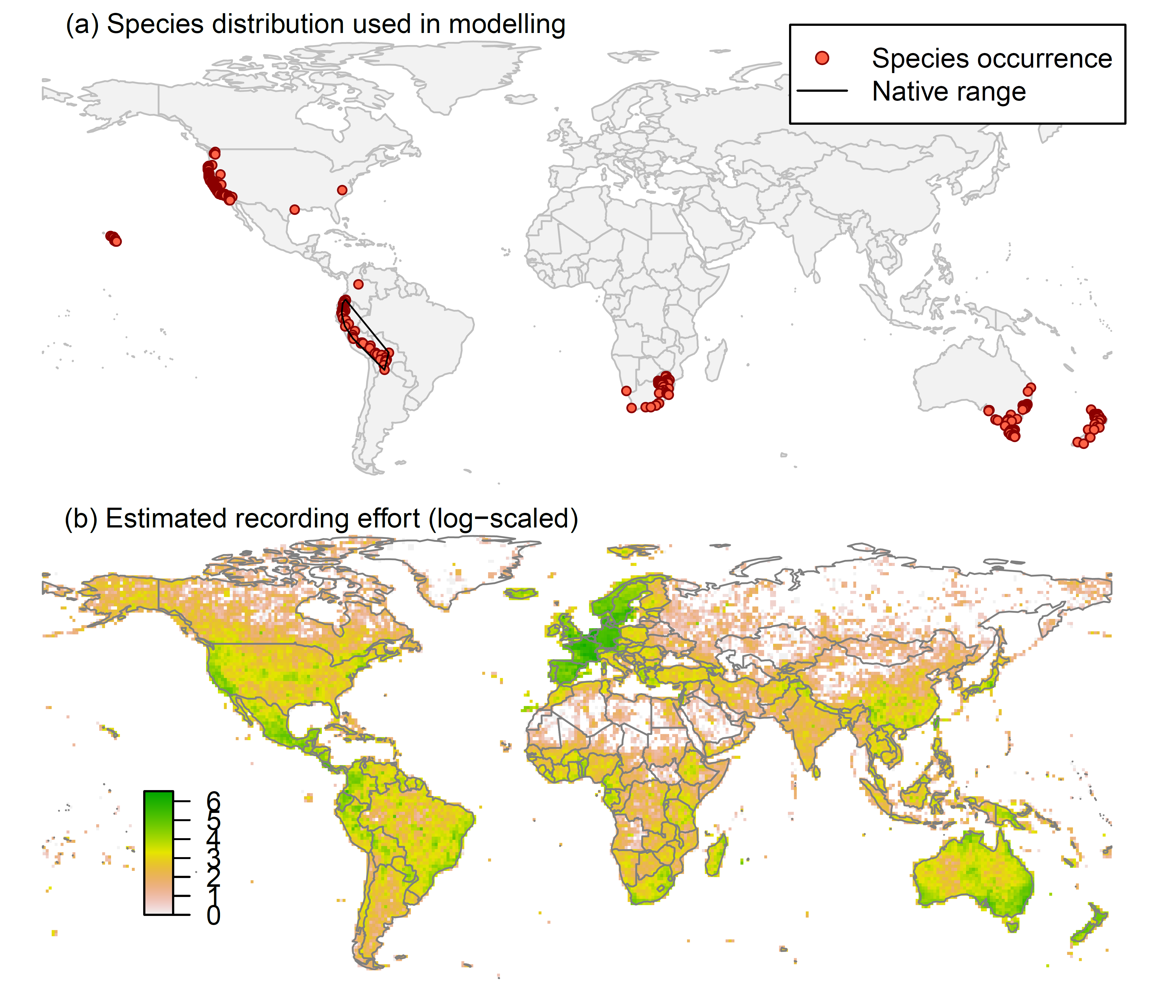

Figure 1. (a) Occurrence records obtained for Cortaderia jubata and used in the modelling, showing the native range and (b) a proxy for recording effort – the number of Tracheophyta records held by the Global Biodiversity Information Facility, displayed on a log₁₀ scale.

Species distribution model
A presence-background (presence-only) ensemble modelling strategy was employed using the BIOMOD2 R package v3.3-7 (Thuiller et al., 2014, Thuiller et al., 2009). These models contrast the environment at the species’ occurrence locations against a random sample of background environmental conditions (often termed ‘pseudo-absences’) in order to characterise and project suitability for occurrence. This approach has been developed for distributions that are in equilibrium with the environment. Because invasive species’ distributions are not at equilibrium and subject to dispersal constraints at a global scale, we took care to minimise the inclusion of locations suitable for the species but where it has not been able to disperse to. Therefore the background sampling region included:

- The area accessible by native C. jubata populations (see Fig. 1a), in which the species is likely to have had sufficient time to disperse to all locations. The native range was defined as the occurrences in Ecuador, Peru and Bolivia. We assumed the record in Colombia was an introduction. The accessible region was defined as a 300 km buffer around the minimum convex polygon bounding all native occurrences; AND
- A relatively small 30 km buffer around all non-native occurrences, encompassing regions likely to have had high propagule pressure for introduction by humans and/or dispersal of the species; AND
- Regions where we have an a priori expectation of high unsuitability for the species (see Figure 2). Absence from these regions is considered to be irrespective of dispersal constraints. A combination of ecophysiological information and the distribution data were used to quantify maximum exposure to factors likely to determine the native range margins and limit occurrence in Europe. The following rules for unsuitability were applied:
  - Mean minimum temperature of the coldest month (Bio6) < -5 °C. Severe frosts cause damage to C. jubata (CABI, 2017) and only 1% of occurrences have lower Bio6 than this, suggesting it is a minimum tolerance.
  - Mean temperature of the warmest quarter (Bio10) < 8 °C. This is reported as the minimum germination temperature for C. jubata (CABI, 2017) and just 0.7% of occurrences have lower Bio10.
  - Climatic moisture index < 0.15. C. jubata is considered relatively drought tolerant but probably needs at least some summer moisture (CABI, 2017). Overall, only 1% of records were in drier locations.
To sample as much of the background environment as possible, without overloading the models with too many pseudo-absences, ten background samples of 10,000 randomly chosen grid cells were obtained (Figure 2). To account for recording effort bias, sampling of background grid cells was weighted in proportion to the Tracheophyte recording density (Figure 1b).

Figure 2. Randomly selected background grid cells used in the modelling of Cortaderia jubata, mapped as red points. Points are sampled from the native range, a small buffer around non-native occurrences and from areas expected to be highly unsuitable for the species (grey background region), and weighted by a proxy for plant recording effort (Figure 1b).

Each dataset (i.e. combination of the presences and the individual background samples) was randomly split into 80% for model training and 20% for model evaluation. With each training dataset, ten statistical algorithms were fitted with the default BIOMOD2 settings (except where specified below) and rescaled using logistic regression:
- Generalised linear model (GLM)
- Generalised boosting model (GBM)
- Generalised additive model (GAM) with a maximum of four degrees of freedom per effect.
- Classification tree algorithm (CTA)
- Artificial neural network (ANN)
- Flexible discriminant analysis (FDA)
- Multivariate adaptive regression splines (MARS)
- Random forest (RF)
- MaxEnt
- Maximum entropy multinomial logistic regression (MEMLR)
Since the background sample was much larger than the number of occurrences, prevalence fitting weights were applied to give equal overall importance to the occurrences and the background. Normalised variable importance was assessed and variable response functions were produced using BIOMOD2’s default procedure. Model predictive performance was assessed by calculating the Area Under the Receiver-Operator Curve (AUC) for model predictions on the evaluation data, that were reserved from model fitting. AUC can be interpreted as the probability that a randomly selected presence has a higher model-predicted suitability than a randomly selected absence.

An ensemble model was created by first rejecting poorly performing algorithms with relatively extreme low AUC values and then averaging the predictions of the remaining algorithms, weighted by their AUC. To identify poorly performing algorithms, AUC values were converted into modified z-scores based on their difference to the median and the median absolute deviation across all algorithms (Iglewicz & Hoaglin, 1993). Algorithms with z < -2 were rejected. In this way, ensemble projections were made for each dataset and then averaged to give an overall suitability.
Global model projections were made for the current climate and for the two climate change scenarios, avoiding model extrapolation beyond the ranges of the input varaibles. The optimal threshold for partitioning the ensemble predictions into suitable and unsuitable regions was determined using the ‘minimum ROC distance’ method. This finds the threshold where the Receiver-Operator Curve (ROC) is closest to its top left corner, i.e. the point where the false positive rate (one minus specificity) is zero and true positive rate (sensitivity) is one.

Limiting factor maps were produced following Elith et al. (2010). For this, projections were made separately with each individual variable fixed at a near-optimal value. These were chosen as the median values at the occurrence grid cells. Then, the most strongly limiting factors were identified as the one resulting in the highest increase in suitability in each grid cell. Partial response plots were also produced by predicting suitability across the range of each predictor, with other variables held at near-optimal values.

Results
The ensemble model suggested that suitability for C. jubata was most strongly determined by the minimum temperature of the coldest month (Table 1), with exclusion from places < -3.6 °C (Figure 3). The models also estimated weaker restriction of suitability through low PET, drought, lack of human disturbance and low summer temperatures. For these weaker effects, there was substantial variation among modelling algorithms in the partial response plots (Figure 3).

Global projection of the model in current climatic conditions indicates that the native and known invaded records generally fell within regions predicted to have high suitability (Figure 4). The model predicts a high potential for further expansion of the currently-invaded non-native ranges of the species in Australia and the Middle East, as well as potential for the species to establish in parts of the world in which it has not currently invaded such as southern Africa and northern Argentina (Figure 4).

The projection of suitability in Europe and the Mediterranean region suggests that C. jubata may be capable of establishing widely in southern and western Europe and in north Africa, the Middle East and around the Black and Caspian Seas (Figure 5). In eastern and northern Europe, cold winters are predicted to limit establishment (Figure 6). The uncertainty of these predictions for Europe, in terms of disagreement among algorithms, was greatest around the predicted margin between suitability and unsuitable conditions (Figure 4)

By the 2070s, under the moderate RCP4.5 and extreme RCP8.5 climate change scenarios, the suitability region in Europe is predicted to expand north eastwards with little loss of suitability in the currently-suitable region (Figures 7-8). This is driven by a relaxation of winter cold in eastern and northern Europe, causing the model to predict suitability for estbalishment.

In terms of Biogeographical Regions (Bundesamt fur Naturschutz (BfN), 2003), those predicted to be most suitable for C. jubata establishment in the current climate are Mediterranean, Atlantic, Macaronesia and Black Sea (Figure 9). The climate change scenarios evaluated have the effect of substantially increasing predicted suitability in the Pannonian, Continental, Anatolian and Steppic regions (Figure 9).

Table 1. Summary of the cross-validation predictive performance (AUC) and variable importances of the fitted model algorithms and the ensemble (AUC-weighted average of the best performing algorithms). Results are the average from models fitted to ten different background samples of the data.
Algorithm | Predictive AUC | Used in the ensemble | Variable importance
Algorithm | Predictive AUC | Used in the ensemble | Minimum temperature of coldest month | Mean temperature of warmest quarter | Potential evapotranspiration | Climatic moisture index | Human influence index
GAM | 0.9540 | yes | 57% | 6% | 21% | 6% | 10%
MARS | 0.9510 | yes | 74% | 1% | 6% | 17% | 1%
GBM | 0.9506 | yes | 73% | 4% | 7% | 9% | 7%
Maxent | 0.9505 | yes | 72% | 3% | 8% | 9% | 8%
FDA | 0.9492 | yes | 73% | 0% | 20% | 6% | 1%
GLM | 0.9484 | yes | 60% | 9% | 17% | 5% | 9%
CTA | 0.9252 | no | 65% | 12% | 12% | 10% | 1%
RF | 0.9232 | no | 57% | 8% | 15% | 6% | 14%
MEMLR | 0.8992 | no | 45% | 25% | 5% | 14% | 12%
ANN | 0.8977 | no | 51% | 13% | 21% | 3% | 12%
Ensemble | 0.9543 |  | 68% | 4% | 13% | 9% | 6%

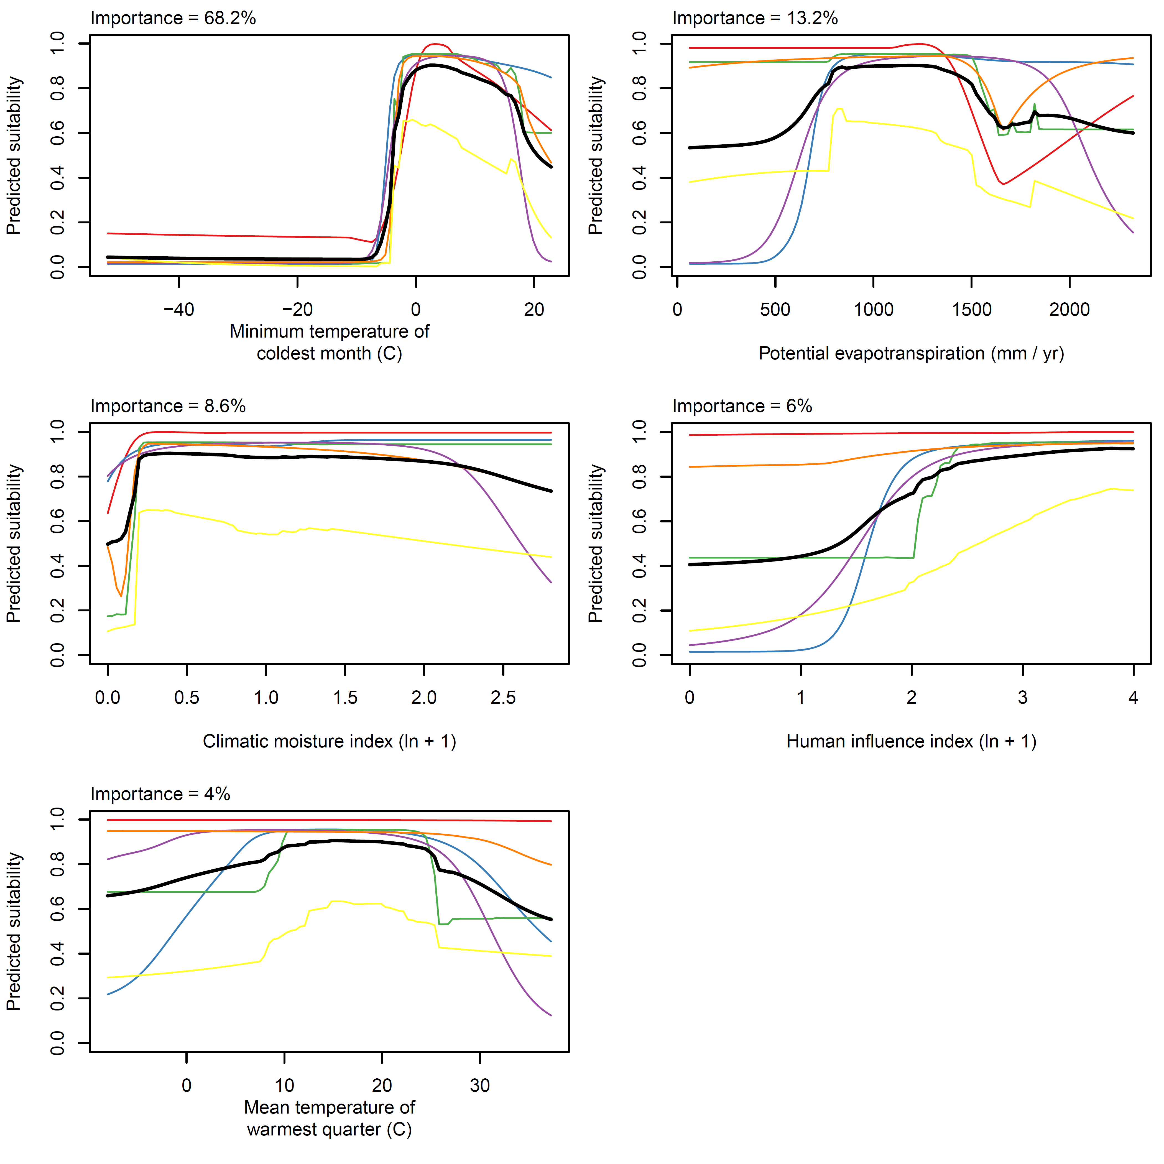
Figure 3. Partial response plots from the fitted models, ordered from most to least important. Thin coloured lines show responses from the algorithms in the ensemble, while the thick black line is their ensemble. In each plot, other model variables are held at their median value in the training data. Some of the divergence among algorithms is because of their different treatment of interactions among variables.

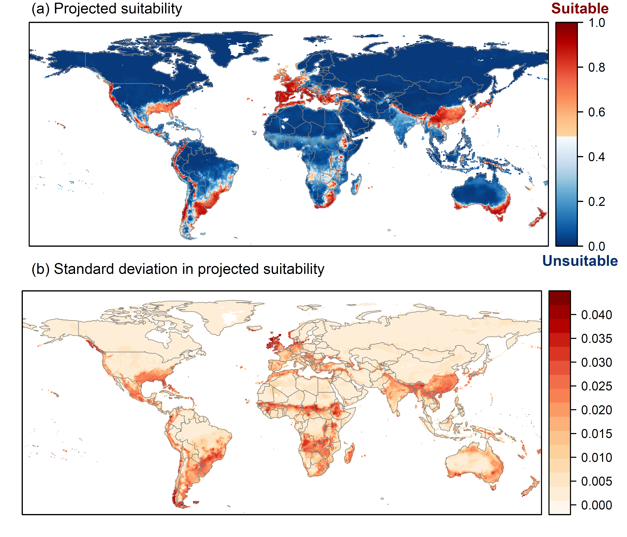
Figure 4. (a) Projected global suitability for Cortaderia jubata establishment in the current climate. For visualisation, the projection has been aggregated to a 0.5 x 0.5 degree resolution, by taking the maximum suitability of constituent higher resolution grid cells. Red shading indicates suitability. White areas have climatic conditions outside the range of the training data so were excluded from the projection. (b) Uncertainty in the suitability projections, expressed as the standard deviation of projections from different algorithms in the ensemble model.

Figure 5. Projected current suitability for Cortaderia jubata establishment in Europe and the Mediterranean region. The white areas have climatic conditions outside the range of the training data so were excluded from the projection.

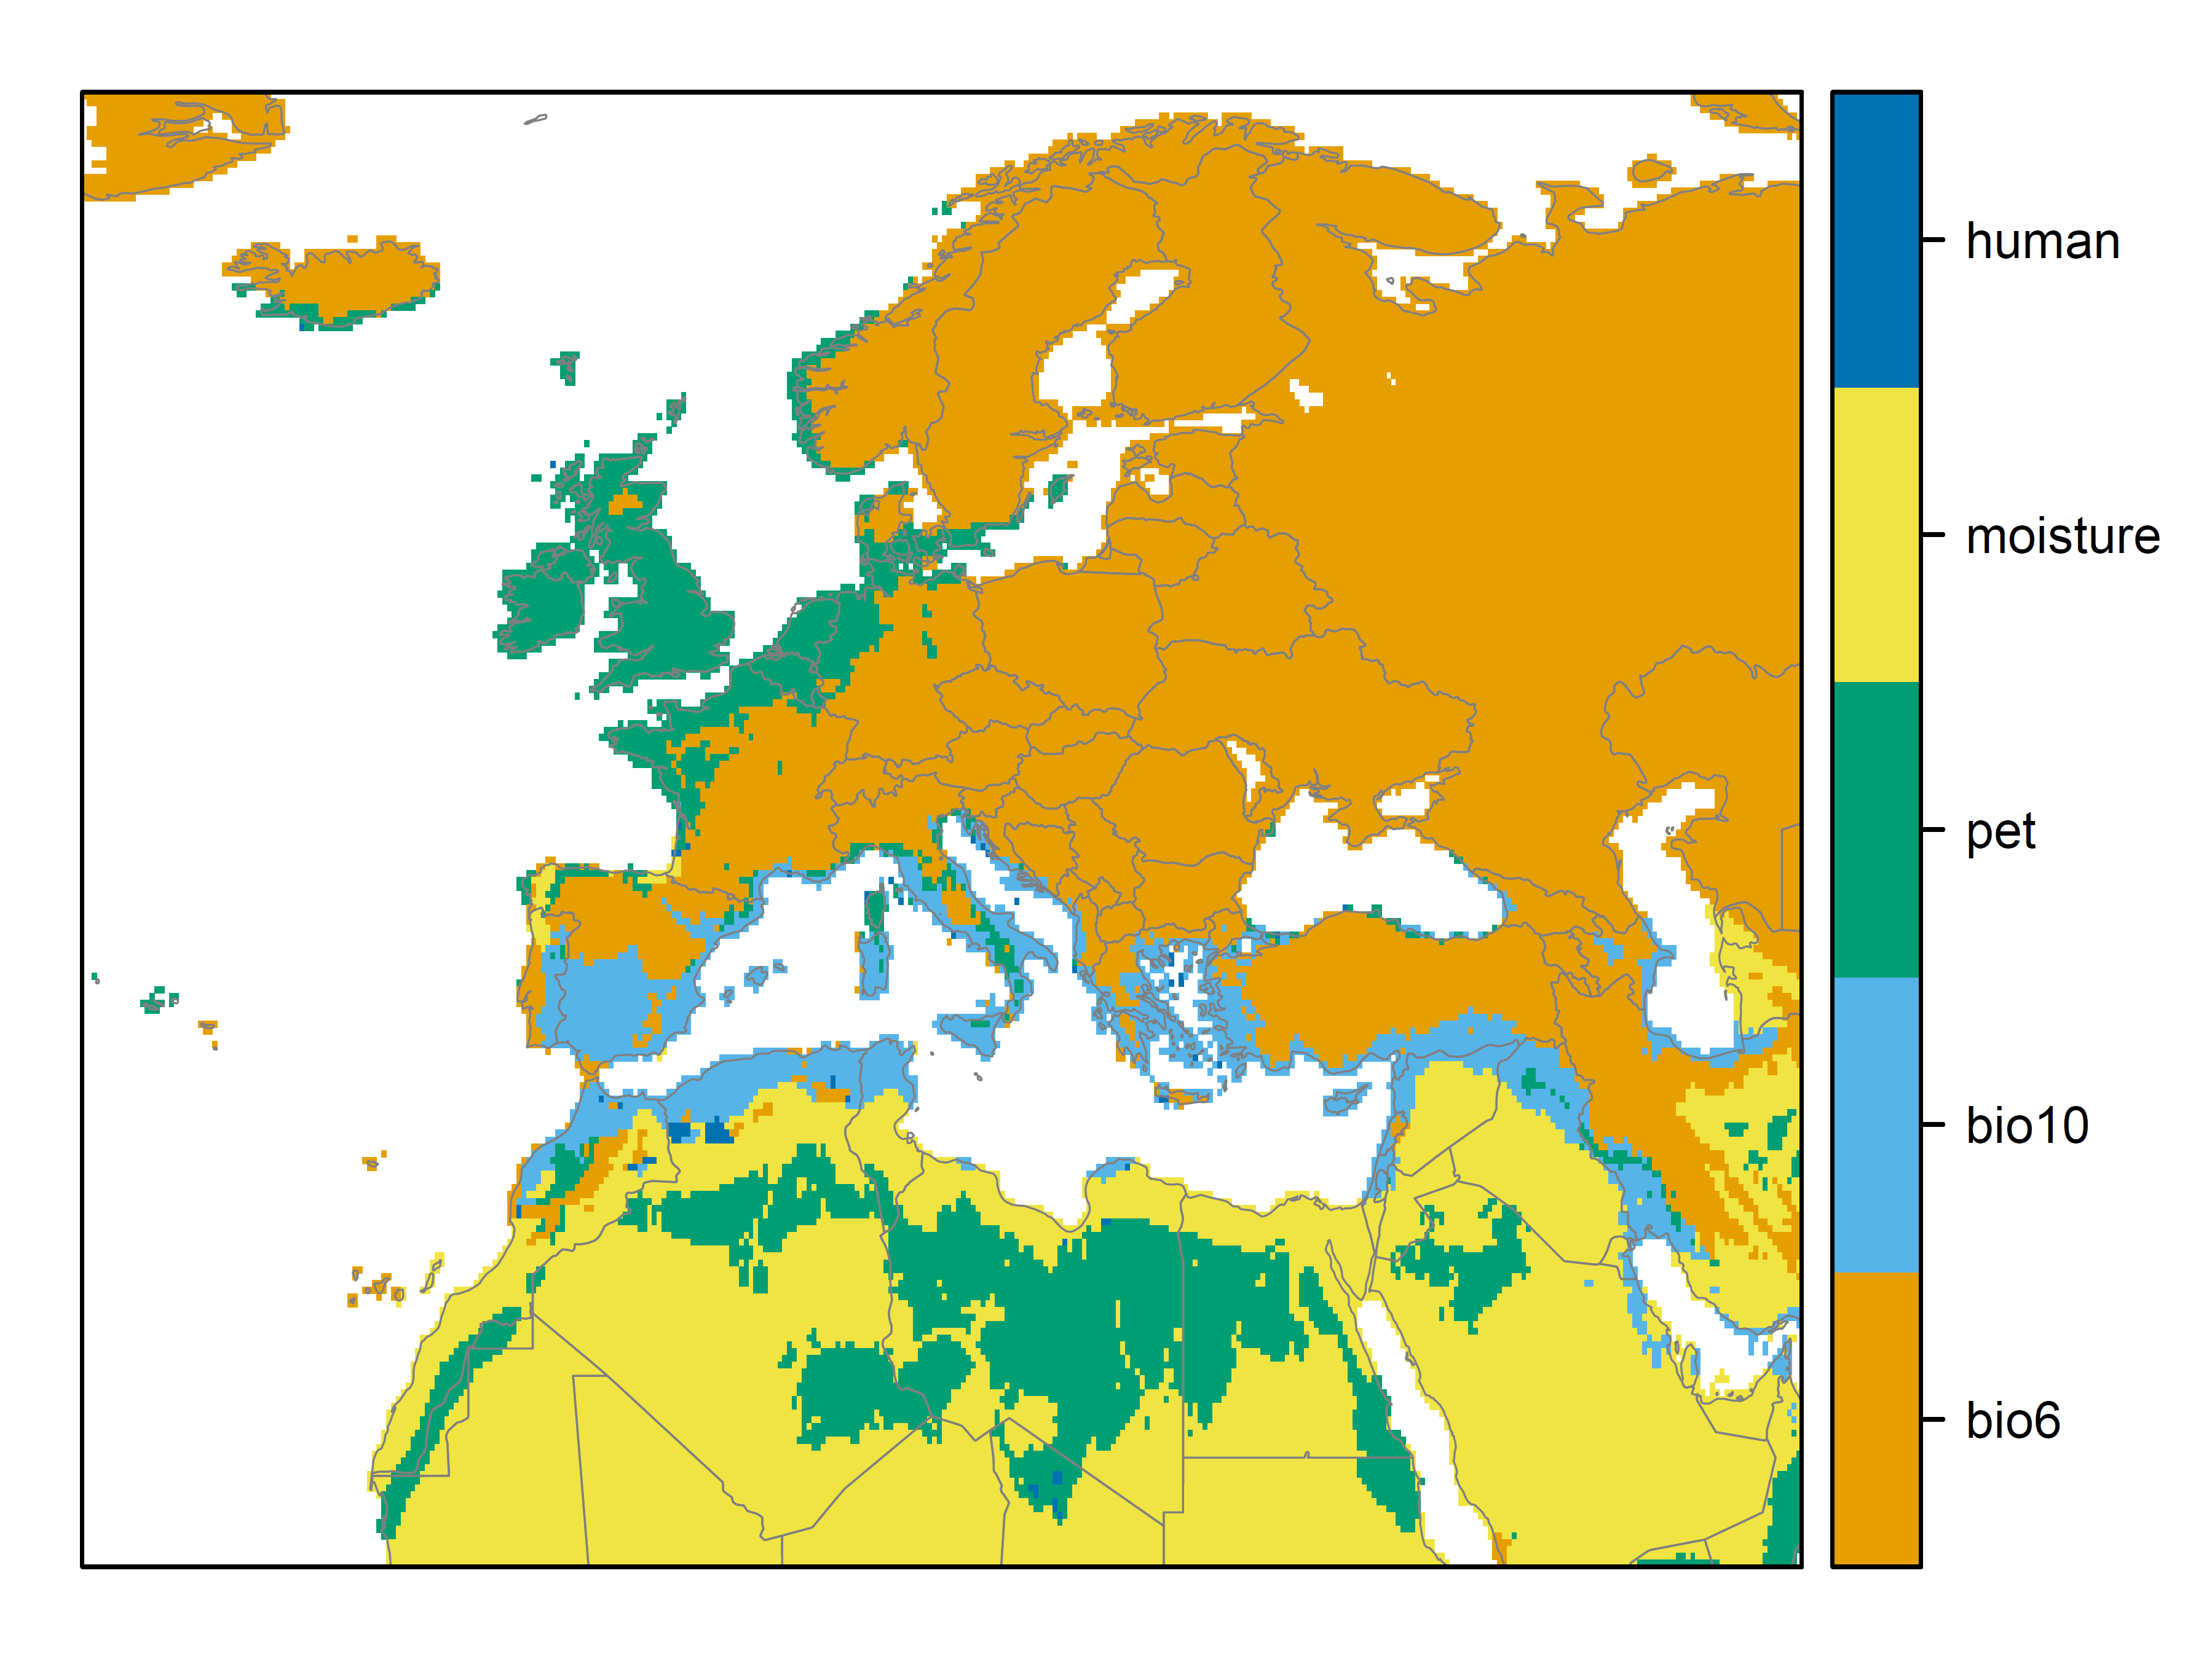
Figure 6. Limiting factor map for Cortaderia jubata establishment in Europe and the Mediterranean region in the current climate. Shading shows the predictor variable most strongly limiting projected suitability. The axis represents// Human: Human influence index as C. jubata, like many invasive species, is likely to associate with anthropogenically disturbed habitats; moisture: Climatic moisture index (CMI, ratio of mean annual precipitation, Bio12, to PET) reflecting plant moisture regimes. C. jubata occurs in a range of moisture regimes, but establishes most readily in moist habitats; Pet: Annual potential evapotranspiration (PET mm yr⁻¹) was included as an alternative measure of energy availability, accounting for solar radiation. Monthly PETs were estimated from the WorldClim monthly temperature data and solar radiation using the simple method of Zomer et al. (2008) which is based on the Hargreaves evapotranspiration equation (Hargreaves, 1994); bio10: Mean temperature of the warmest quarter (Bio10 °C) reflecting the growing season thermal regime. Cool temperatures might limit reproductive output and germination is known to be inhibited by cold temperature (CABI, 2017); bio6: Mean minimum temperature of the coldest month (Bio6 °C) reflecting exposure to frost. C. jubata is reported as being damaged by prolonged frost (CABI, 2017).

Figure 7. Projected suitability for Cortaderia jubata establishment in Europe and the Mediterranean region in the 2070s under climate change scenario RCP4.5, equivalent to Figure 5.

Figure 8. Projected suitability for Cortaderia jubata establishment in Europe and the Mediterranean region in the 2070s under climate change scenario RCP8.5, equivalent to Figure 5.

Figure 9. Variation in projected suitability among Biogeographical regions of Europe (Bundesamt fur Naturschutz (BfN), 2003). The bar plots show the proportion of grid cells in each region classified as suitable in the current climate and projected climate for the 2070s under emissions scenarios RCP4.5 and RCP8.5. The coverage of each region is shown in the map below.

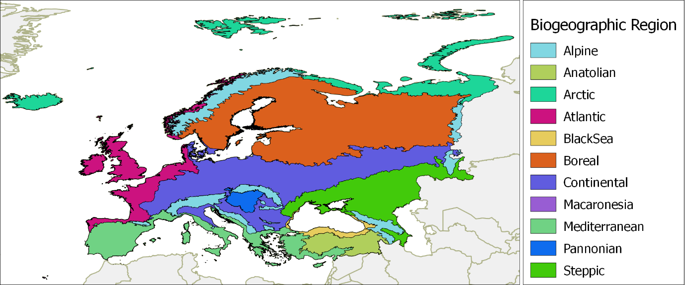

Caveats to the modelling
Modelling the potential distributions of range-expanding species is always difficult and uncertain.
Gaps in occurrence data from the native range (Chile and Argentina) may have affected the model predictions.

Other variables potentially affecting the distribution of the species, such as edaphic variables, were not included in the model.

To remove spatial recording biases, the selection of the background sample was weighted by the density of Tracheophyte records on the Global Biodiversity Information Facility (GBIF). While this is preferable to not accounting for recording bias at all, a number of factors mean this may not be the perfect null model for species occurrence:

- The GBIF API query used did not appear to give completely accurate results. For example, in a small number of cases, GBIF indicated no Tracheophyte records in grid cells in which it also yielded records of the focal species.
- We located additional data sources to GBIF, which may have been from regions without GBIF records.

References
R. J. Hijmans, S. E. Cameron, J. L. Parra, P. G. Jones & A. Jarvis (2005) Very high resolution interpolated climate surfaces for global land areas. International Journal of Climatology 25, 1965-1978.
CABI (2017) Cortaderia jubata (purple pampas grass). In Invasive Species Compendium, Wallingford, UK.
R. J. Zomer, A. Trabucco, D. A. Bossio & L. V. Verchot (2008) Climate change mitigation: A spatial analysis of global land suitability for clean development mechanism afforestation and reforestation. Agriculture, Ecosystems & Environment 126, 67-80.
G. H. Hargreaves (1994) Defining and Using Reference Evapotranspiration. Journal of Irrigation and Drainage Engineering 120.
Wildlife Conservation Society - WCS & Center for International Earth Science Information Network - CIESIN - Columbia University (2005) Last of the Wild Project, Version 2, 2005 (LWP-2): Global Human Influence Index (HII) Dataset (Geographic). NASA Socioeconomic Data and Applications Center (SEDAC), Palisades, NY.
W. Thuiller, D. Georges & R. Engler (2014) biomod2: Ensemble platform for species distribution modeling. R package version 3.3-7 Available at: https://cran.r-project.org/web/packages/biomod2/index.html.
W. Thuiller, B. Lafourcade, R. Engler & M. B. Araújo (2009) BIOMOD–a platform for ensemble forecasting of species distributions. Ecography 32, 369-373.
B. Iglewicz & D. C. Hoaglin (1993) How to detect and handle outliers. Asq Press.
Bundesamt fur Naturschutz (BfN) (2003) Map of natural vegetation of Europe. Web site: http://www.bfn.de/. National data included.

Appendix 2 Biogeographical regions

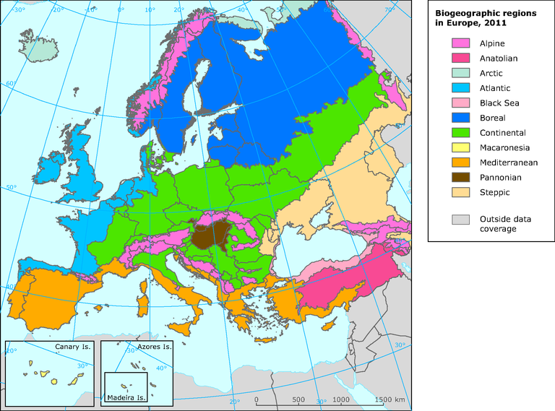

Appendix 3. Relevant illustrative pictures (for information)

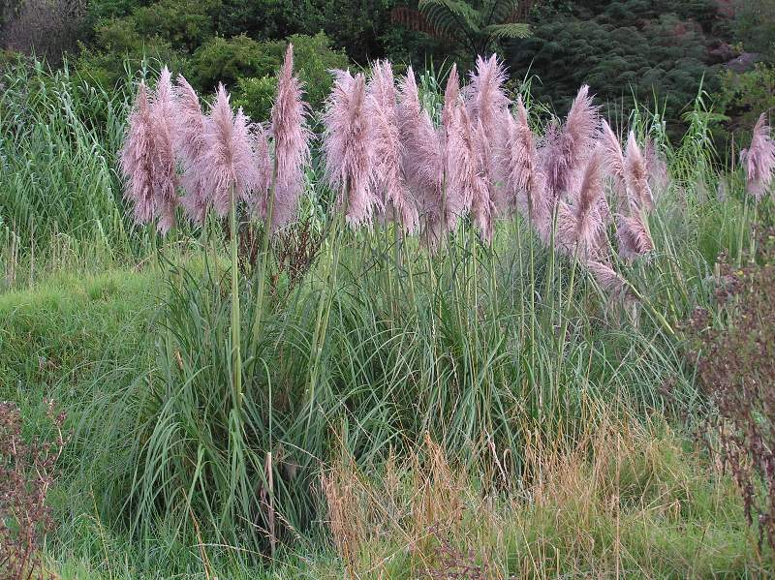

Figure 1. Cortaderia jubata showing pink colour inflorescences

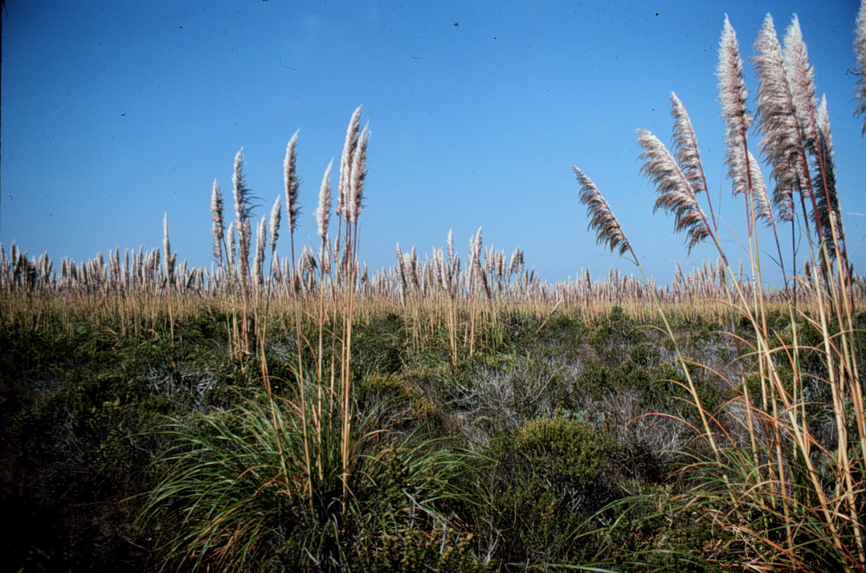

Figure 2. Cortaderia jubata invasion in North America

Plate 1.

Cortaderia jubata

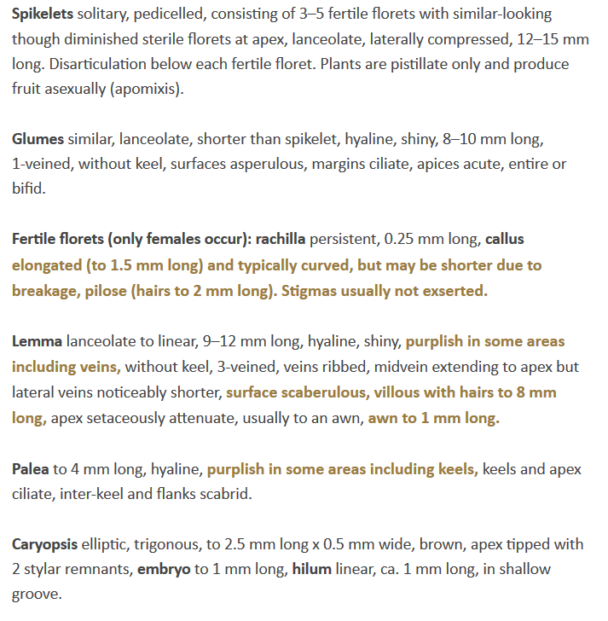

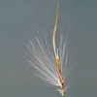
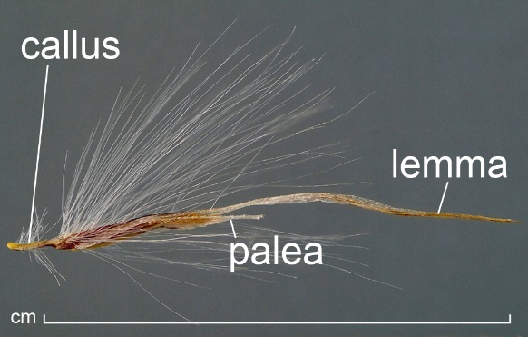

Plate information taken from: http://idtools.org/id/table_grape/weed-tool/key/GrapeGrassKey/Media/Html/fact_sheets/Cor-sel.html

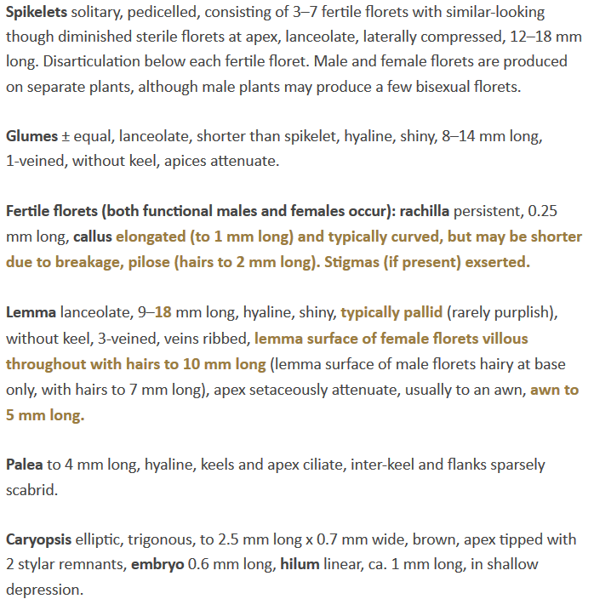
Plate 2.
Cortaderia selloana

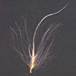
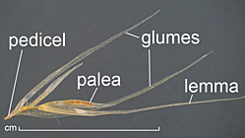

Plate information taken from: http://idtools.org/id/table_grape/weed-tool/key/GrapeGrassKey/Media/Html/fact_sheets/Cor-jub.html

Appendix 4: Distribution summary for EU Member States and Biogeographical regions
Member States:
 | Recorded | Established (currently) | Established (future) | Invasive (currently)
Austria | – | – | YES | –
Belgium | – | – | YES | –
Bulgaria | – | – | YES | –
Croatia | – | – | YES
Cyprus | – | – | YES | –
Czech Republic | – | – | YES | –
Denmark | – | – | YES | –
Estonia | – | – | – | –
Finland | – | – | – | –
France | – | – | YES | –
Germany | – | – | YES | –
Greece | – | – | YES | –
Hungary | – | – | YES | –
Ireland | – | – | YES | –
Italy | – | – | YES
Latvia | – | – | – | –
Lithuania | – | – | – | –
Luxembourg | – | – | YES | –
Malta | – | – | YES | –
Netherlands | – | – | YES | –
Poland | – | – | YES | –
Portugal | – | – | YES | –
Romania | – | – | YES | –
Slovakia | – | – | YES | –
Slovenia | – | – | YES | –
Spain | – | – | YES | –
Sweden | – | – | YES | –
United Kingdom | – | – | YES | –

Biogeographical regions
 | Recorded | Established (currently) | Established (future) | Invasive (currently)
Alpine
Atlantic | – | – | YES | –
Black Sea | – | – | YES | –
Boreal | – | – | – | –
Continental | – | – | YES | –
Mediterranean | – | – | YES | –
Pannonian | – | – | YES | –
Steppic | – | – | – | –

YES: if recorded in natural environment, established or invasive or can occur under future climate; – if not recorded, established or invasive; ? Unknown

Appendix 5: Distribution maps
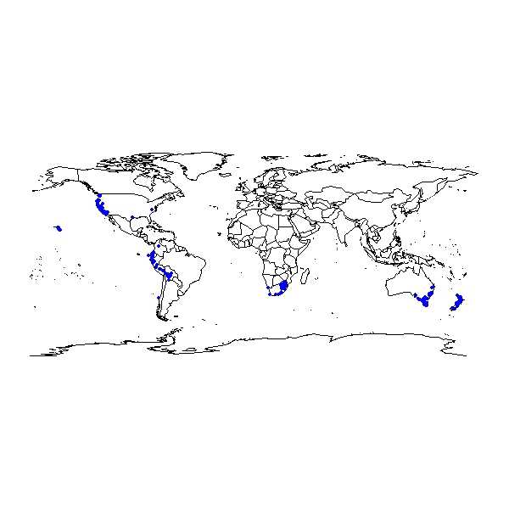

Fig. 1 Distribution maps for world map

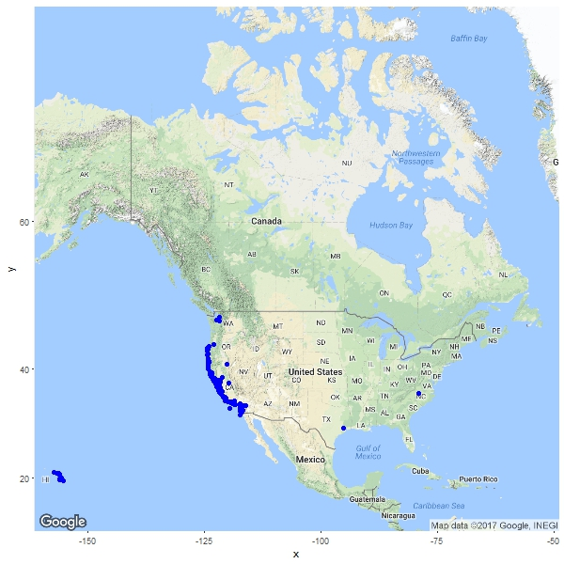

Fig. 2. Distribution map for Cortaderia jubata in North America

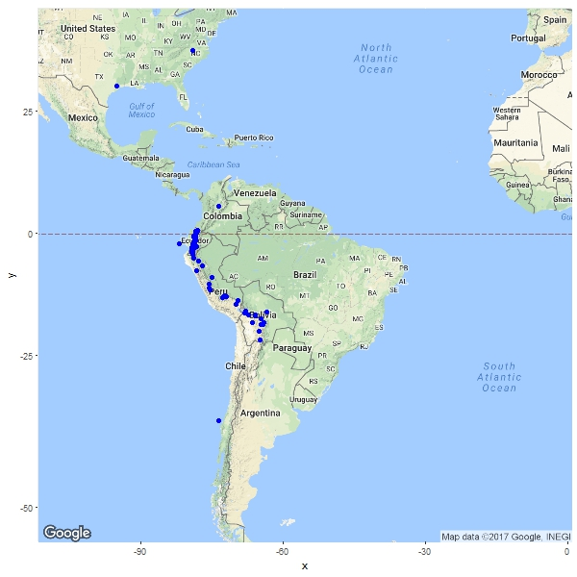

Fig. 3. Distribution map for Cortaderia jubata in South America

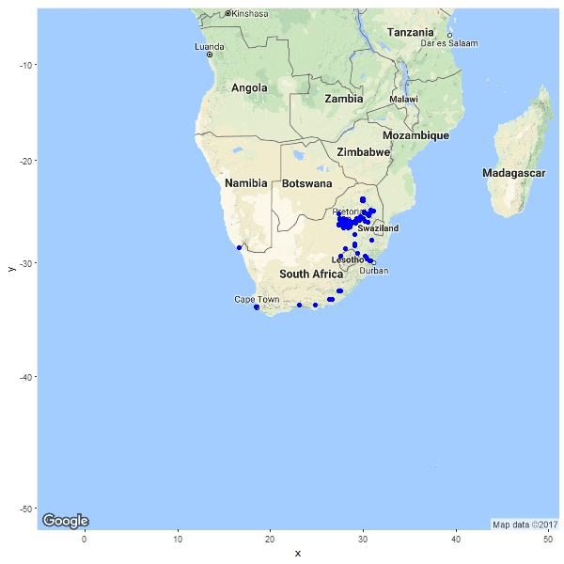

Fig. 4. Distribution map for Cortaderia jubata in South Africa

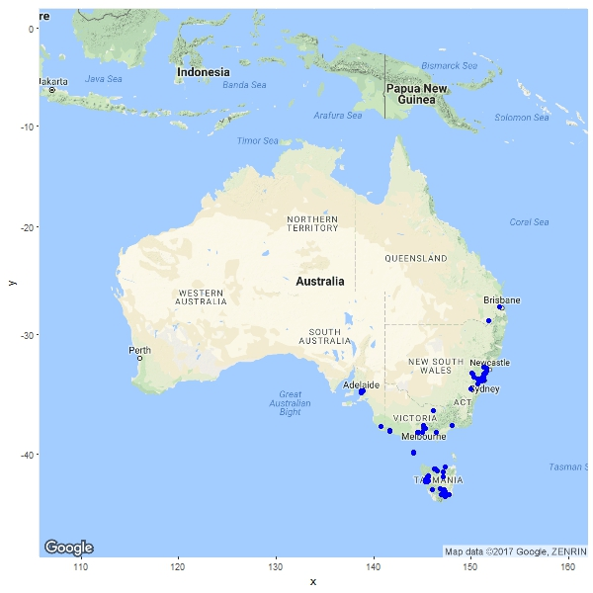

Fig 5. Distribution map of Cortaderia jubata in Australia

The summary should be elaborated once the analysis is completed
http://ec.europa.eu/environment/nature/invasivealien/docs/Prioritising%20prevention%20efforts%20through%20horizon%20scanning.pdf
See also appendix 4: Distribution summary for EU Member States and Biogeographical regions
Note maps in Appendix 5 may contain records, e.g. herbarium records, that were not considered during the climate modelling stage. Date to compile the maps were taken from various sources including GBIF, scientific literature and grey material.

